Architecture Description Document
MSLite
(Complete)

Table of Contents
1. Executive Summary 9
2. Architecture Documentation Roadmap 9
2.1. Description of the Architecture Documentation 9
2.2. How Stakeholders Can Use the Documentation 10
3. System Overview 11
3.1. System Context 11
3.2. Requirements 12
3.3. Quality Requirements 18
3.4. Constraints 21
4. Architecture View Template 22
5. Software Architecture Views 22
5.1. Component and Connector Views 22
5.1.1. C&C View Packet 1: The MSLite System 23
5.1.2. C&C View Packet 2: Publish Subscribe Connector 32
5.1.3. C&C View Packet 3: Virtual FSS Component 36
5.1.4. C&C View Packet 4: FSS Adapter Component (Configuration Synchronization) 39
5.1.5. C&C View Packet 5: Presentation Component 42
5.1.6. C&C View Packet 6: Alarm Component 45
5.2. Process View 48
5.3. Module Views 51
5.3.1. Module View Packet 1: MSLite 52
5.3.2. Module View Packet 2: Presentation 56
5.3.3. Module View Packet 3: Rules 58
5.3.4. Module View Packet 4: Publish Subscribe 61
5.3.5. Module View Packet 5: Virtual FSS 62
5.3.6. Module View Packet 6: Adapter 63
5.3.7. Module View Packet 7: Data 65
5.4. Deployment View 66
5.5. Project Layout View 68
5.5.1. Binary output directory 71
5.5.2. Source directory 71
5.5.3. MSLite module projects 71
5.5.4. Project references 72
5.5.5. Assumptions 73
5.6. Behavioral Specification 73
5.6.1. Logon 73
5.6.2. Logoff 75
5.6.3. Editing a Hierarchy 76
5.6.4. View Properties 77
5.6.5. Issue Command 78
5.6.6. Alarm Rule 80
5.6.7. Publish COV 90
5.6.8. Generate Alarm 91
5.6.9. Acknowledge Alarm 93
5.6.10. Dismiss Alarm 94
5.6.11. Configuration Synchronization 95
5.6.12. MSLite Startup 96

Table of figures
Figure 1: MSLite system context 12
Figure 2: MSLite user interface 13
Figure 3: UCP000 – Top level use case package 16
Figure 4: UCP100 – Manage Hierarchies use case package 17
Figure 5: UCP200 – Manage LnR Rules use case package 18
Figure 6: UCP200 – Manage alarm rules use case package 18
Figure 7: The MSLite system 24
Figure 8: Decomposition of the Publish Subscribe connector 33
Figure 9: Decomposition of the Virtual FSS 37
Figure 10: Decomposition of the FSS Adapter 40
Figure 11: Decomposition of the Presentation component 42
Figure 12: Decomposition of the Alarm component 46
Figure 13: Process view 49
Figure 14: Module decomposition of the MSLite system 53
Figure 15: Decomposition of the Presentation module 56
Figure 16: Decomposition of the Rules module 59
Figure 17: Publish-subscribe module 61
Figure 18: Decomposition of the Virtual FSS module 62
Figure 19: Decomposition view of the Adapter 64
Figure 20: Decomposition of Data 65
Figure 21: Deployment of MSLite components 67
Figure 22: Structure of the MSLite file system 69
Figure 35: Logon sequence diagram 75
Figure 36: Logoff sequence diagram 76
Figure 37: Sequence diagram for editing a hierarchy 77
Figure 38: Sequence diagram for editing a hierarchy 78
Figure 39: Success scenario during issuing command 79
Figure 40: Failure scenario during issuing command 80
Figure 41: Display Alarm Rules sequence diagram 81
Figure 42: Delete Alarm Rules sequence diagram 81
Figure 43: Duplicate Alarm Rules sequence diagram 82
Figure 44: Change Alarm Rule Status sequence diagram 83
Figure 45: Create Alarm Rule sequence diagram 84
Figure 46: Edit Alarm Rule sequence diagram 85
Figure 47: Display L&R Rules sequence diagram 86
Figure 48: Delete L&R Rules sequence diagram 86
Figure 49: Duplicate L&R Rules sequence diagram 87
Figure 50: Change L&R Rules sequence diagram 88
Figure 51: Create L&R Rules sequence diagram 89
Figure 52: Edit L&R Rule sequence diagram 90
Figure 53: Publish COV sequence diagram 91
Figure 54: Alarm generation sequence diagram for MSLite 92
Figure 55: FSS alarm generation sequence diagram 93
Figure 56: Acknowledge Alarm sequence diagram 94
Figure 57: Dismiss Alarm sequence diagram 95
Figure 58: Configuration Synchronization sequence diagram 96
Figure 59: MSLite Startup sequence diagram showing initialization of Value Cache 97
Figure 60: MSLite Startup sequence diagram showing initialization of Adapter Manager 97
Figure 61: MSLite Startup sequence diagram showing initialization of Alarm and
L&R processes 98
Table of tables
Table 1: Quality attribute requirements for MSLite 19
Table 2: MSLite component catalog 24
Table 3: MSLite connector catalog 28
Table 4: Publish Subscribe subcomponents 34
Table 5: Publish Subscribe connectors 36
Table 6: Virtual FSS subcomponents 37
Table 7: Virtual FSS connectors 38
Table 8: FSS Adapter subcomponents 41
Table 9: FSS Adapter connectors 41
Table 10: Presentation subcomponents 43
Table 11: Presentation connectors 44
Table 12: Alarm subcomponents 47
Table 13: Alarm connectors 48
Table 14: Process view elements 49
Table 15: Process view relations 51
Table 16: MSLite system modules 53
Table 17: MSLite system module dependencies 55
Table 18: Sub-modules of the Presentation module 57
Table 19: Sub-modules of the Rules module 60
Table 20: Publish-subscribe module responsibilities 62
Table 21: Sub-modules of Virtual FSS and their responsibilities 63
Table 22: Adapter sub-modules 64
Table 23: Data sub-modules 66
Table 24: Deployment view element catalog 67
Table 25: File system element catalog 69

Executive Summary
E-House is a company that primarily sells hardware devices to manage the internal functions of a building. Each product line has a software system that manages these devices but this constitutes a loss leader, i.e. they lose money on the software but it helps the sale of the hardware devices. The company realizes that the hardware is being commoditized and over time the profit margins on the sale of their hardware devices are going to shrink. E-House would like to:
- Reduce development costs: Consolidate all existing software systems for managing hardware devices for building automation into a single unified management system called MSLite.
- Create new revenue streams: Charge existing customers for the management system, enter new and emerging geographic markets, and open new sales channels by partnering with value added resellers (VARs).
This document describes the architecture of MSLite. The factors serving as the primary motivator for and having the most profound influence on this architecture include:
- MSLite system will serve as a single unified management station for the building automation domain that will automatically monitor and/or control the internal functions of buildings, such as heating, ventilation, air conditioning, lighting, access, and safety.
- The architecture must enable VARs to sell MSLite for hardware systems developed by other vendors.

Architecture Documentation Roadmap
The roadmap gives an overview of the structure and content of the entire architecture description document, and provides guidance on how different stakeholders might want to view the various sections.

Description of the Architecture Documentation
The MSLite architecture description contains the following sections:
Section 1, Executive Summary, provides a summary of this document with emphasis on business goals motivating this project.
Section 2, Architecture Documentation Roadmap, lists and outlines the contents of the overall documentation package including how the various sections address different stakeholder concerns. This is the first section that a new stakeholder must read.
Section 3, System Overview, gives a description of the system’s context, a broad set of requirements it must satisfy and some of the major design constraints. The purpose is to help the reader understand what the architecture is trying to achieve.
Section 4, Architectural View Template, explains how the architectural views are described in the document. The purpose is to help the reader understand the information provided for each of the architectural views in this document.
Section 5, Software Architecture Views, describes a number of different views of the architecture that can be divided into three broad categories – module, component-and- connector, and allocation views. The purpose of each view is to address specific stakeholder concerns and serve as the basis for the following type of architectural design decisions:
- How is the system to be structured as a set of code units? (module views)
- How is the system to be structured as a set of elements that have runtime behavior and interactions? (component-and-connector views)
- How is the system to relate to the non-software structures in its environment? (allocation views)

How Stakeholders Can Use the Documentation
All stakeholders must read the executive summary section to understand the business goals motivating this project and system overview section to gain a broad understanding of the requirements driving the development of the MSLite system. In addition, the following list enumerates the different stakeholder roles of primary importance to the MSLite system and describes, for each stakeholder role, the sections of this document that might be most relevant for addressing their concerns.
- Someone new to the project: Read the architecture documentation roadmap section for an overview of the structure and content of the architecture documentation, and decide sections of the document most relevant to address the concerns for your assigned role. Read the view template section to understand how each view of the architecture is documented before studying view(s) most relevant to your role.
- Project manager: Module views show the implementation units of MSLite and how they depend on each other. This information can be used as a basis for work allocation among the development teams. The component-and-connector view can help identify components that will have to be qualified, procured and integrated. The deployment view will provide information on hardware environment to be acquired and the testing environment to be set up.
- Software architect: Module views can be used to reason about static development-time qualities of the system such as modifiability and portability. The component-and-connector views help reason about runtime quality attribute requirements the architecture must adhere to such as performance and availability. They can also be used to infer progression of data through the system and runtime behavior of the system.
- Performance engineer: The component-and-connector views can be used for understanding the behavior of the system. The process view can show runtime representation of MSLite and its processes. The deployment view can be used to understand how software is allocated to hardware.
- Security analyst: The component-and-connector views can be used for understanding the interaction among the runtime components of MSLite. The deployment view provides information on the physical environment in which these components operate.
- Developer: Module views can show the implementation units of the system and their dependencies. The component-and-connector views can help infer progression of data through the system and runtime behavior of the system. Project layout view can provide information where the implementation artifacts of MSLite reside within the file system.
- Maintainer: Module views can provide information on the various subsystems of MSLite and how they depend on each other. The component-and-connector views should provide information on the software components that exist and their responsibilities. This information can be useful as a starting point for future extensions or modifications.
- Customer/Acquirer: Read the component-and-connector and the deployment views to gain an understanding of how the system is structured to carry out its mission, and to gain an appreciation for the work that must be done to build it.
- Users: The component-and-connector views should provide basic understanding for the structure of the system and how its various parts behave.

System Overview
In order to realize the company’s vision, it is important to understand the context for the MSLite system, an overview of its requirements, and any major constraints on how it must be designed. Together this information becomes an input to creating the architecture for the MSLite system, and it provides the reader a broad understanding of what the architecture is trying to achieve.

System Context
Figure 1 shows a context diagram depicting the external entities with which the MSLite system interacts. Field System Simulator (FSS) is a component that will simulate the functionality of field systems (building automation hardware devices). FSS Configuration File describes the field systems and their property values that the FSS simulates. User/Operator represents a person who is using the MSLite system. There can be multiple concurrent users such as facilities manager, field engineers and systems administrators.
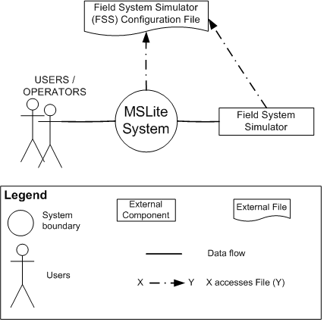
Figure 1: MSLite system context

Requirements
The MSLite system allows management of field systems, their properties and their hierarchies. A field system (any building automation hardware device such as a temperature sensor, a humidity sensor, a fan controller, a door latch or a smoke detector) is logically represented as field object inside the FSS. A property is an attribute exposed by a field object. For example typical properties exposed by a temperature sensor would be current temperature and operating status (which can have the value such as normal, fault or maintenance). A hierarchy is a logical structure organizing the presentation of field objects. Hierarchies are presented in a tree structure with logical nodes and leaves. Logical nodes can represent rooms or buildings and leaves can represent field objects in the rooms or the buildings (this is similar to the Windows Explorer with nodes being analogous to folders and the field objects analogous to files). Hierarchies are user-definable and each user can have multiple hierarchies. In order to include a field object in a hierarchy the user must have read rights to at least one property of the field object. This hierarchy can only be owned and managed by the user that created it.
A representation of MSLite is shown in Figure 2.
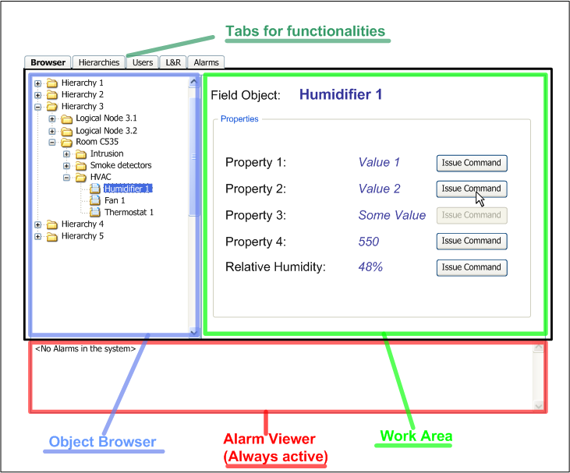
Figure 2: MSLite user interface
The user interface (UI) of MSLite shown in Figure 2 represents a workspace that contains the following elements:
- The Work Area: The Work Area displays the properties of the field object currently selected in the Object Browser (properties to which the user does not have read access are not displayed in the Work Area).
- The Object Browser: The Object Browser displays multiple hierarchies of field objects. Each hierarchy is initially displayed as one collapsed parent node. Collapsing/Expanding of hierarchies is identical to the behavior of the standard Windows tree UI component.
- The Alarm Viewer: The Alarm Viewer displays all alarms in reverse chronological order, i.e. as a stack (Last In First Out) - with the newest alarm on top. Only alarms with the status as either not acknowledged or acknowledged are displayed. Dismissed alarms are not displayed.
The Object Browser and the Work Area are a part of a section of the UI that can be manipulated using tabs (each tab maps to a separate functionality). The Alarm Viewer can never be replaced – it is always active and cannot be closed.
A user with a valid username and password can log in to the system and see all hierarchies that he/she has created. When a user logs in, the user's interaction with the system happens within a session. When a user logs off, the system will remember his/her selection in the object browser and the user will see that selection in the object browser (and the associated view in the work area) upon login.
The UI shows the current value of all properties of all field objects. These values are updated when a change of value event occurs. A change of value (COV) is an event generated by FSS that represents a change in the value of a property of a field object inside the FSS. This event will consist of a property identifier, its new value, and the timestamp of occurrence. All COV events will have the same priority. The UI receives notification of the COV events and reflects the updated values. A user with write access to a property can issue a command from the UI to change the value of that property of a field object.
A user can also define logic and reaction (L&R) rules. An L&R rule has two parts, a logical condition and a reaction. A logical condition evaluates if a certain property of a certain field object meets, exceeds, or falls below a certain value. A reaction is a command issued automatically by MSLite when its corresponding logical condition evaluates to true. L&R rules can only be defined by a user if the user has read access to all properties that are part of the logical condition and write access to the property affected by its reaction. There can be only one reaction in every L&R rule – the user can create multiple L&R rules with the same logical condition but different reactions. In this case, it is also possible to specify the sequence of the rule execution.
Alarms are a special kind of an L&R rule used for alerting when properties of field objects go into an abnormal state. Alarms are triggered in a user-independent context. This implies that when an alarm condition is met, MSLite automatically generates an alarm. It is displayed in the work area as a request for acknowledging the alarm. This is displayed to all logged in users who have read access to the associated alarm property for the alarm. Any user can acknowledge an alarm displayed in the work area. All alarms in the alarm viewer are displayed in reverse chronological order, i.e. as a stack (Last In First Out) - with the newest alarm on top.
Figure 3 through Figure 6 show some significant use cases supported by MSLite. The use cases are logically grouped into packages. The top level use case package (UCP000), shown in Figure 3, contains all use cases and use case packages. Some significant use cases included in this package are:
- UC 001: Issue Command – The user selects a field object property to modify. Specifies the new value of the property and sees the change reflected in the UI.
- UC 002: Manage Change of Value – FSS sends a notification of a COV to the system. The system updates its internal object model, updates the UI and potentially executes rules and alarms.
- UC 003: Trigger L&R Rule – A received COV event changes the system status so that a logical condition is evaluated to the value = "true" and this causes the execution of a reaction (equivalent to the issuance of a command).
- UC 004: Generate Alarm – A received COV event changes the system status so that an alarm condition is evaluated to the value = "true" and this causes the generation of an alarm.
- UC 005: Acknowledge Alarm – After an alarm is generated, a user acknowledges the alarm. The system updates the UI accordingly for all logged in users.
- UC 006: Browse Hierarchy - A user browses a hierarchy in the hierarchy browser by expanding and collapsing logical nodes and selecting field objects of which the system displays the accessible properties in the work area.
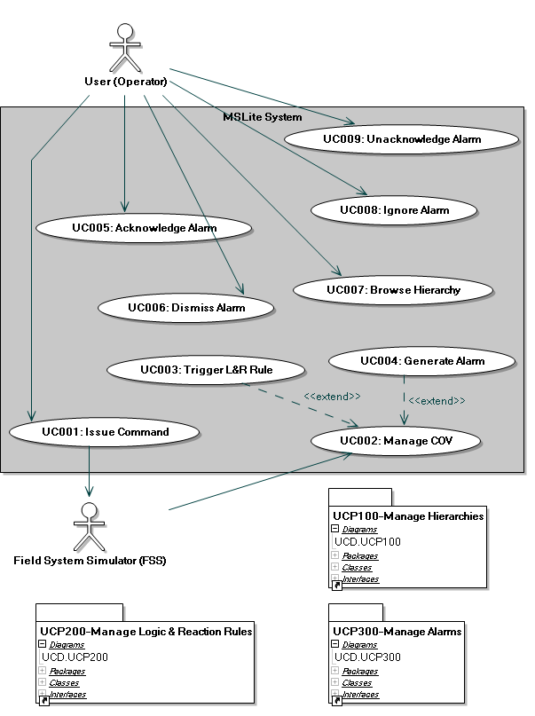
Figure 3: UCP000 – Top level use case package
The Manage Hierarchies use case package (UCP100) shown in Figure 4 contains all use cases related to operations on hierarchies. These operations include creation, editing and deletion of hierarchies. This package also includes a set of extending use cases which detail the construction steps of a hierarchy.
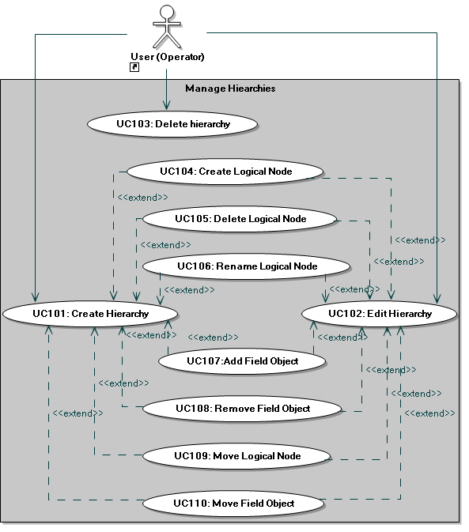
Figure 4: UCP100 – Manage Hierarchies use case package
The Manage L&R Rules use case package (UCP200) shown in Figure 5 contains all use cases related to creation, editing and deletion of Logic & Reaction Rules.
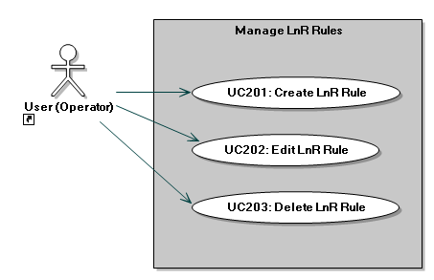
The Manage Alarm Rules use case package (UCP300) shown in Figure 6 contains all use cases related to creation, editing and deletion of Alarm Rules.
Figure 5: UCP200 – Manage L&R Rules use case package

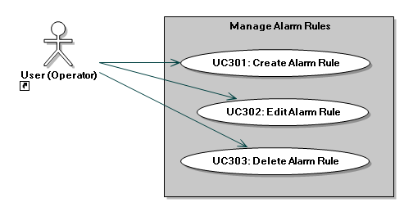
Figure 6: UCP200 – Manage alarm rules use case package

Quality Requirements
Quality attributes requirements (also known as non-functional requirements) describe properties or characteristics of MSLite that are not directly implementable with source code. Quality attributes help define the structure of MSLite and are described in terms of scenarios that identify specific instances of the use of MSLite.
The quality attributes of MSLite along with their scenarios are described in the table below. Each scenario is prioritized based on feedback from the stakeholder and the architecture team. The priority of a scenario is done on a relative scale and is given as a tuple of the following:
- The importance of each scenario to the success of MSLite.
- The degree of difficulty posed by the achievement of the scenario during the estimation phase.
For the first element of the tuple, the measures used for priority are as follows:
- High: If this scenario cannot be satisfied, the system will be considered a failure.
- Medium: This scenario is highly desirable for the system; however, if this scenario cannot be satisfied by the system because of a good reason, the system will not be considered a failure.
- Low: This scenario is nice to have.
For the second element of the tuple, the measures used for priority are as follows:
- High: The architecture team does not know how to do it.
- Medium: The architecture team knows how to do it, but it is difficult to do.
- Low: The architecture team knows how to do it and it is considered easy.

Table 1: Quality attribute requirements for MSLite
Quality Attribute | Attribute Characterization | Attribute Scenarios | Priority
Modifiability | Support for multiple FSS | M1. An additional FSS must be connected to MSLite to support another discipline. MSLite is reconfigured off-line to support the additional FSS instance without development. | (H , L)
Modifiability | Support for new FSS | M2. A new FSS (NFSS) has been developed. NFSS offers functionality comparable to FSS, but configuration information is in a different format and details of the interface (calling conventions, method names, etc.) are different. A team of 4 developers who are reasonably comfortable with C# extends MSLite to support NFSS in 144 person hours (12 h per week and person, 3 weeks). | (M , M)
Modifiability | Support for extended FSS | M3. An extended FSS (EFSS) has been developed that supports generation of alarms and functional commands instead of just change of value notifications. A team of 4 developers who are reasonably comfortable with C# extends MSLite to support EFSS-generated alarms and EFSS functional commands in 240 person hours (12 h per week and person, 5 weeks). | (H , H)
Performance | Latency of event/alarm propagation | P1. A field system detects a change of property value and notifies MSLite. The system operates under normal conditions¹. The value is updated on all user screens that display the old value within 3 seconds.  P2. An alarm occurs, either originating in a field system or in MSLite. The system operates under normal conditions². The alarm is displayed on the user interfaces of all users that must receive the alarm within 3 seconds. The time durations specified in this scenario are performance goals and are not to be taken as hard deadlines. | (M , M)
Reliability | Alarm/Event propagation | R1. The FSS sends 1000 COV notifications per minute for 2 minutes. The MSLite system will preserve any notifications that are initiated from either the MSLite system or from the FSS. Hence, no notifications or events can be lost. | (H , L)
Security | Data access control | S1. An MSLite user wants to view the details and / or change the value of a property of a field object on a GUI screen. The user is logged in and read / write access to this property might be restricted. Depending on the user's permissions, MSLite grants or denies access to this property. | (M , M)
Usability | Alarm / event display | U1. The FSS notifies MSLite of a new event that is not an alarm. This non-alarm event is associated to a property ‘x’. MSLite is operating under normal conditions³. There are ‘n’ users logged into MSLite. There are ‘m’ users that have read privileges to property ‘x’. Only relevant GUI screens for these ‘m’ users will reflect the update. | (H , M)
¹,²,³ Normal conditions are temporarily specified as follows:
- number of concurrent sessions connected to MSLite: 15
- COV Rate: Less than 600 COVs per minute. (30 field object properties at 20COVs/Minute)
- Active LnR Rules: 20
- Active Alarm Rules: 20

Constraints
Constraints are defined as limitations or bounds within which the MSLite system must be created. For MSLite, the following constraints have been identified:
- Technology
  - MSLite must run on a machine using Microsoft Windows XP operating system with the .NET Framework version 1.1
  - Software system must run as a web based application where web pages must be developed using ASP.NET 1.1 and run on IIS server software version 5.1
  - All source code must be developed using the C# programming language
  - MSLite must use MySQL 4.1 as its database
  - Targeted client browsers are Internet Explorer 5.5 or greater

- External Systems
  - The system must provide an interface that allows integration with the existing FSS. This should include:
    - All functionality provided by the FSS
    - All notifications received from the FSS
    - All commands that can be issued to the FSS
    - Error handling for errors/exceptions thrown by the FSS

Architecture View Template
The architecture of MSLite will be described using a set of views. Each view helps address specific concerns and will be documented using a Primary Presentation – a graphical presentation that shows the key system elements and the relationships among them, and an Element Catalog - a catalog details at least those elements and relations depicted in the primary presentation, along with a rationale that explains why the design in this view came to be.

Software Architecture Views
The purpose of each view is to address specific stakeholder concerns. The subsequent sections describe a component and connector view, and an allocation view that serve as the basis for the following type of architectural design decisions:
- How is the system to be structured as a set of code units? (module views)
- How is the system to be structured as a set of elements that have runtime behavior and interactions? (component-and-connector views)
- How is the system to relate to the non-software structures in its environment? (allocation views)

Component and Connector Views
The Component & Connector (C&C) view-type partitions the system into components that have some runtime presence such as processes, objects, data stores and connectors or that represent pathways of communication such as information flows, and access to shared storage. This view-type was selected because it helps the following roles:
- The software architect and project manager can argue and reason about architectural properties and quality attribute requirements that the system must adhere to.
- The software architect, programmer and tester can infer progression of data through the system and how the structure of the system changes as it executes.
- External stakeholders like customers, project evaluators can understand the system’s principal executing components (including the major shared data sources) and their interactions – therefore serving as a means for verification and validation of system properties.
- Maintainers of the project can get an overview of the system as a starting point of future extensions and / or modifications.
The view-type has been represented using a combination of the call-return and publish-subscribe styles because separating these two predominant styles into different views would have reduced the understandability of the system as a whole. The interactions of the different components in this view-type warrant the combination of the styles and they individually adhere to the rules of the aforementioned styles.

C&C View Packet 1: The MSLite System
The view shows a high level run time view of the MSLite system in terms of indicating what entities are responsible for what functionalities, where MSLite information is stored and how commands and events travel in MSLite.
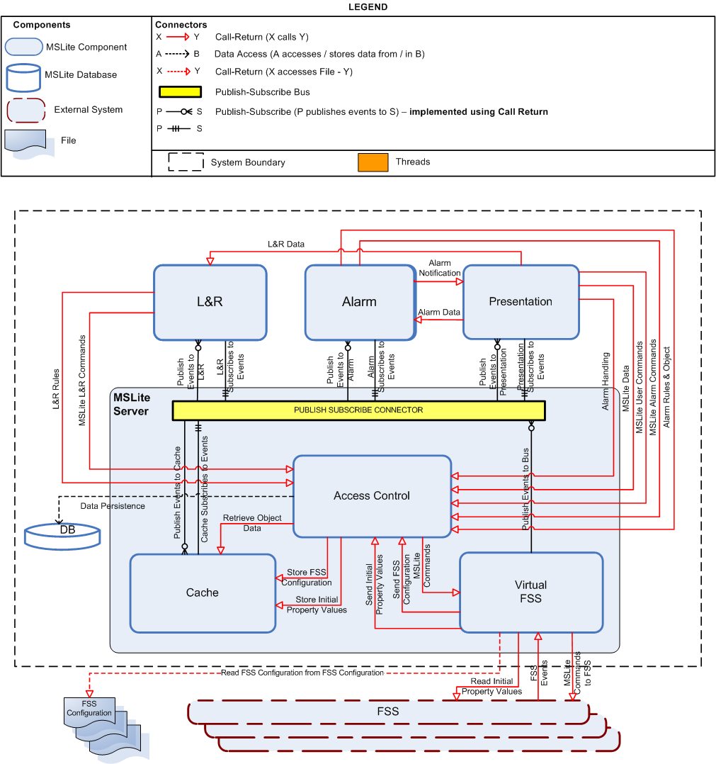
Figure 7: The MSLite system
Table 2 and Table 3 describe the different components and connectors of the MSLite system.
Table 2: MSLite component catalog
Component | Responsibilities
MSLite Server | - Controls all of the Logic for:  - Handling the communication with the multiple FSSs  - Storage and retrieval of the field object data to and from the Cache and the Database  - Handling the subscription and publication of all events in the system  - Handling the events triggered from the FSSs (including COVs, NCOVs and alarms)  - To perform these operations it contains the:  - Virtual FSS  - Access Control  - Cache  - Publish Subscribe Connector
L&R | - Managing L&R rules including persisting them in a local cache:  - LR.1) Create L&R rule  - LR.2) Edit L&R rule  - LR.3) Delete L&R rule  - LR.4) Trigger L&R rule:  - Subscribe to COVs  - Evaluate L&R rules  - Trigger reactions (equivalent to issuing commands and therefore referred to as MSLite L&R Commands)
Presentation | - Responsible for the following UI elements:  - UI.1)Work Area  - UI.2)Object Browser including:  UI.2) a) Display hierarchies  UI.2) b) Collapse/Expand hierarchy  - UI.3) Alarm Viewer including:  UI.3) a) Display alarms  - L&R rules including persisting them to the database  LR.1) Create L&R rule  LR.2) Edit L&R rule  LR.3) Delete L&R rule  - Alarm rules including persisting them to the database  AL.1) Create alarm rule  AL.2) Edit alarm rule  AL.3) Delete alarm rule  AL.4) b) Display alarm acknowledgement request  AL.4) c) Display alarm  AL.5) Acknowledge alarm  AL.5) a) Removerequest from other users' screens  AL.5) b) Change alarm status in Alarm Viewer  AL.6) Dismiss alarm  - Managing Hierarchies including:  MH.1) Create hierarchy  MH.2) Edit hierarchy  MH.2) a) Rename hierarchy or hierarchy description  MH.2) b) Add logical nodes  MH.2) c) Rename logical nodes  MH.2) d) Delete logical nodes  MH.2) e) Add field objects  MH.2) f) Remove field objects  MH.3) Delete hierarchy  - Issuing Commands including:  IC.1) User issues commands from UI  IC.2) UI sends command to MSLite  IC.4) UI reflect successful transmission of command to FSS  IC.5) UI reflects failed transmission of command to FSS  - COV.1) UI shows current value - Subscribe to COV events based on displayed property values
Alarm | This component handles the entire lifecycle of alarms within MSLite:  - Managing Alarms including persisting them in a local cache:  AL.1) Create alarm rule  AL.2) Edit alarm rule  AL.3) Delete alarm rule  - Notify Presentation of newly generated alarms including:  AL.4) c) Display alarm  - AL.4) Trigger alarm rule including:  - Subscribing to COV events based on alarm rules  - Trigger Alarms - (equivalent to issuing commands and therefore referred to as MSLite Alarm Commands)  - AL.4) a) Persist alarm  - Future Extension: Subscribe to all alarm events generated from the FSS  - Future Extension: Send alarm acknowledgement to FSS
Access Control | - AC.1) Configure access rights statically - including persisting them in the database and in the cache. TBD  - Important: Allow access to all MSLite, L&R and Alarm data based on user rights.  - Note: MSLite needs a way to authorize and authenticate users as they try to use MSLite and the data within MSLite. The existence of Access Control introduces another computation in the processing of end-user data requests. This directly affects computational performance of MSLite as authorization and authentication require their own processing time. Without the functional requirement to control access to data and the security concern of data access control, the Access Control component could be removed and the speed of MSLite processing for data requests hence improved. This is a trade-off between performance and security for MSLite. An increase in security decreases performance and vice versa.
DB | - Persist all hierarchy information  - AC.1) Configure access rights statically - Persist MSLite users and permissions in the database. TBD  - Persist L&R rules in the database for:  - LR.1) Create L&R rule  - LR.2) Edit L&R rule  - LR.3) Delete L&R rule  - Persist alarm rules in the database for:  - AL.1) Create alarm rule  - AL.2) Edit alarm rule  - AL.3) Delete alarm rule  - AL.4) a) Persist alarm  - SM.1) Synchronize MSLite with FSS configuration - Persist FSS configuration (using field object templates and instances)  - Persist hierarchies in the database for Managing Hierarchies including:  - MH.1) Create hierarchy  - MH.2) Edit hierarchy
Cache | - Store field object property values for easy access
Virtual FSS | - Publish all COV events to MSLite  - Execute all commands specified from MSLite  - Read FSS configuration and store it in the MSLite database  - Read initial property values from the FSS and store them in the MSLite cache  Future Extension: Publish all Alarm events to MSLite
FSS | THIS IS AN EXTERNAL SYSTEM AND IS A GIVEN FOR MSLite  - Publish all FSS (COV) Events  - Execute all commands specified by MSLite  - Provide initial property values to MSLite  - Read FSS configuration  Note:There can be multiple FSS. In this version of MSLite however, there will be only one.
FSS Configuration | THIS IS AN EXTERNAL ENTITY (FILE) AND IS A GIVEN FOR MSLite  - Provide FSS configuraton to both the FSS and to MSLite  Note:There can be multiple FSS Configuration files - one for each FSS. In this version of MSLite however, there will be only one FSS and therefore one FSS Configuration File.

Table 3: MSLite connector catalog
Connector | Responsibilities
Publish Subscribe | - A publish-subscribe connector was used because:  - MSLite does not know subscribers to FSS events in advance and there can be dynamic subscribers.  - Events from the FSS are asynchronous.  - Not all components interested in the same events.  - The events are stored in a first-in first-out (FIFO) buffer in the publish-subscribe. Only one event is released at a time and it is sent to all subscribers concurrently.  - There is currently 1 kind of event that flows through the publish-subscribe connector:  - COV Event  Future Extension: The Publish Subscribe Connector can be used to manage Alarm Events as well.
Publish Events to L&R | - Publishes COV events to the L&R component that the L&R component is subscribed to.
L&R Subscribes to Events | - The L&R component is subscribed to all COV events at startup.TBD
Publish Events to Presentation | - Publishes COV events to the Presentation component that the Presentation component has subscribed to.  Important:These events are user specific, e.g., user 'A' viewing a property 'APROP" (and therefore subscribed to the COV for APROP 'APROPCOV') will receive notification of 'APROPCOV' and another user 'B' viewing a property 'BPROP' (and therefore subscribed to the COV for BPROP 'BPROPCOV') will receive notification of 'BPROPCOV'.
Presentation Subscribes to Events | - The Presentation component is subscribed to COV events for properties that are being viewed by the user and are therefore user specific.  Important:These subscriptions are user specific, e.g., user 'A' viewing a property 'APROP" is subscribed to the COV for APROP 'APROPCOV' (and therefore will receive notification of 'APROPCOV') and another user 'B' viewing a property 'BPROP' is subscribed to the COV for BPROP 'BPROPCOV'( and therefore will receive notification of 'BPROPCOV').
Publish Events to Alarm | - Publishes COV events to the Alarm component that the Alarm component is subscribed to.
Alarm Subscribes to Events | - The Alarm component is subscribed to all COV events at startup. TBD
L&R Data | - Requests the L&R component to update the L&R rules when new L&R rule has been created or an existing L&R rule has been edited.
Alarm Data | - Requests the Alarm component to update the Alarm rules when a new Alarm rule has been created or an existing Alarm rule has been edited.
Alarm Handler | - AL.5) Acknowledge Alarm - sends alarm acknowledgements to the Access Control to be sent to the database.  Note: The Alarm Acknowledge may also be routed through the Alarm Components since there is an exensibility requirement to require for FSS to have alarm events and alarm acknowledgements to be sent directly to the FSS.  - Dismiss Alarm - Notify the Access Control about the dismissal of an alarm.  - Retrieve Existing Runtime Alarms - retrieves the details of existing alarms that are persisted in the MSLite Database via the Access Control.  - Retrieve Alarm Viewing Rights - retrieves the users' access rights of all alarms present in the system at runtime via the Access Control.
Alarm Notification | - Notify the Presentation component of a newly generated alarm so that the Presentation component can display an alarm acknowledgement request and display the details of the alarm to be displayed on the Alarm Viewer.
MSLite Alarm Commands | THIS IS A FUTURE EXTENSION  - Issue a command to either dismiss or acknowledge an alarm in the FSS (When the FSS supports alarms).  This command is routed through the Access Control Component to Manage the Access Rights of the FSS.
L&R Rules | - Store L&R data in the database when L&R rules are created, edited or deleted by the Presentation component.  - Retrieve property values and L&R rules from the cache for comparison with L&R rules when new COV events are received.
MSLite L&R Commands | - When a L&R rule evaluates to true, a reactions is triggered - this is equivalent to a command issued by the user with the difference being that this reaction or command is triggered or issued automatically by the L&R component.  This command is routed through the Access Control Component to Manage the Access Rights of the FSS.
MSLite Data | - For the manage hierarchy functionality:  - Retrieve hierarchies and field objects that are user specific.  - Update and / or delete hierarchies as updated by the users  - Retrieve property values from the cache  - For the manage alarms functionality:  - Retrieve alarm rules for editing  - Retrieve alarms and their details to be displayed in the Alarm Viewer.  - For the manage L&R functionality:  - Retrieve L&R rules for editing  - Provide user access verification for all functionalities of the Presentation component.
MSLite User Commands | - Issue a user command to the FSS (via the Virtual FSS) to update a property value that a user has write access to.  This command is routed through the Access Control Component to Manage the Access Rights of the FSS.
Alarm Rules & Object | - Alarm Rules: Store Alarm rules data in the database when Alarm rules are created, edited or deleted by the Presentation component.  - Alarm Rules: Retrieve property values from the cache for comparison with Alarm rules when new COV events are received.  - Alarm Objects: When an Alarm condition evaluates to true a new Alarm Object is created by the Alarm Component and this connector persists the details of that Alarm in the Alarm Database.
Publish Events to Bus | - When the Virtual FSS receives a FSS Event (COV) it publishes this event to the Publish Subscribe Bus.
Cache Subscribes to Events | - The Cache is subscribed to all COV events (at startup) so that it can be up to date with the state of the FSS.
Publish Events to Cache | - The Publish Subscribe Bus publishes COV events to the Cache that the Cache is subscribed to (so that it can be updated).
Data Persistence | - All data to be persisted in the database will use this connector
Retrieve Object Data | - Retrieve the Object Data when requested (e.g. by the L&R and Alarm components to compare with L&R and Alarm rules respectively or by a user when the view in the UI changes).
Send FSS Configuration | - Retrieve the FSS Configuration and send it to the Access Control so as instantiate it in the MSLite Cache
Store FSS Configuration | - Store the received FSS Configuration details in the Cache.
Send Initial Property Values | - Retrieve the initial set of property values of the FSS and send it to the Access Control to store them in the MSLite cache
Store Initial Property Values | - Store the received initial set of property values of the FSS in the MSLite cache
Read FSS Configuration from FSS Configuration | - Retrieve the FSS Configuration (to be persisted in the database)
Read Initial Property Values | - Retrieve the initial set of property values of the FSS
FSS Events | THIS IS EXTERNAL TO THE SYSTEM AND WILL NOT BE BUILT BY MSLite DEVELOPERS.  - The FSS notifies MSLite of all COV events occurring within the FSS.
MSLite Commands to FSS | - All MSLite Commands (L&R, User and later Alarm) are sent to the FSS - at this time all commands map to change in property values.

C&C View Packet 2: Publish Subscribe Connector
Figure 8 shows a decomposition of the publish-subscribe connector. During startup and execution of MSLite, all subscribers will register with the Subscription Manager for the appropriate events they would like to receive. An assumption made is that all rule condition evaluations are fast enough to not impact the performance quality attribute.
As also shown in Figure 8, It is important to note that there can be multiple Presentation components depending on the number of logged on users in MSLite.
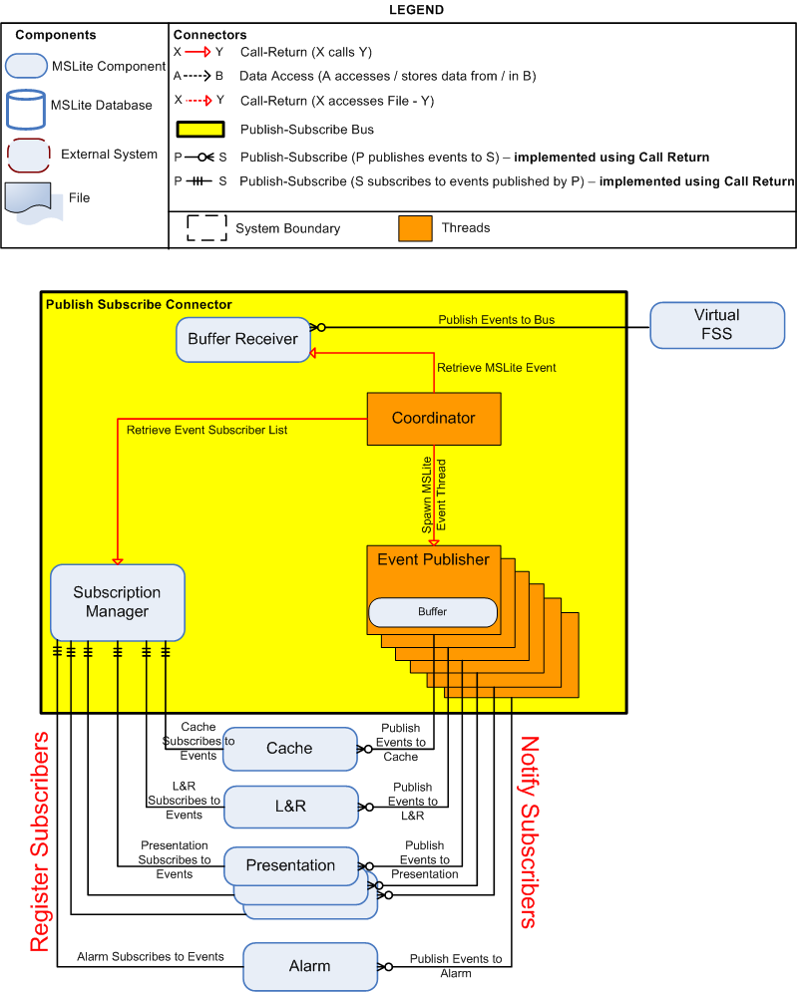
Figure 8: Decomposition of the Publish Subscribe connector
Table 4 and Table 5 describe the different subcomponents and connectors of this Publish Subscribe component.
Table 4: Publish Subscribe subcomponents
Component | Responsibilities
Buffer Receiver | - Receive events from the Virtual FSS  - Stores events in a First In First Out (FIFO) queue  - Upon receiving the first ever event from the Virtual FSS, the Buffer Receiver creates a thread called the Coordinator (Coordinator Component).  - The Buffer Receiver releases events one at a time after each subscribed component has finished its processing tasks for that event.  Note:The functionality of the Buffer Receiver runtime component is important. This is a buffering mechanism that allows events from the FSS to be processed in the order in which they were received. The storage mechanism for this buffer needs to be first-in first-out (FIFO). The reason for the Buffer Receiver component is that MSLite needs to satisfy the reliability quality attribute that states that no events must be lost. Another reason for this component is that we want to make sure that events are captured in the order they were received from the FSS. The use of both the Buffer Receiver and the Coordinator allow MSLite to do proper rule processing which is necessary for handling alarms and the execution of logic and reactions. Buffering introduces performance degradation because events in the buffer do not get processed until all the components that used the prior event are finished processing. To address the issue of performance here, an alternative structure would be using local caches for components that need to process events. Each of these local caches would need to subscribe for events of interest and do their processing. Note though that the possibility exists that these caches perform at different speeds and would hence impact the sequencing desired for alarm and rule evaluation.
Coordinator | - The Coordinator starts processing events one at a time by requesting a single MSLite event from the Buffer Receiver FIFO queue.  - The Coordinator then proceeds to query the Subscription Manager to see who has subscribed (registered) for the event.  - Depending on the number of subscribers to the event, the Coordinator will create that exact number of threads called the Event Publisher(s) to send events to specific subscribers. The Event Publisher(s) will notify their subscribers concurrently.  - Only after the Coordinator receives acknowledgement from all created threads, will it then proceed to process the next event. The Event Publisher thread(s) will then terminate itself.  Note: The use of both the Buffer Receiver and the Coordinator allow MSLite to do proper rule processing which is necessary for handling alarms and the execution of logic and reactions.
Event Publisher | - The Event Publisher sends the event notification to one subscriber  - The Event Publisher waits until processing of the event is complete in the respective subscriber before communicating it back to the Coordinator.  - Each Event Publisher thread will send completion acknowledgement to Coordinator  - Only after the Coordinator receives acknowledgement from all created threads, will it then proceed to process the next event. The Event Publisher thread(s) will then terminate itself.  Note: Event Publishers and the Subscription Manager are necessary to allow for the sequencing of events. Sequencing is accomplished by having all subscribers to an event signal that they are done processing. On that signal, the next buffered event is processed. The call-return connectors only return once all property values used have been accessed. The execution of a rule's action is independent of its condition's evaluation and as such calls return immediately after a rule's condition is evaluated.  - The existence of Event Publishers as threads was to achieve a performance gain to allow for parallel execution instead of blocking occurring every time an event is processed. If threads were not used, the Coordinator component would be responsible for publishing events but this would be a sequential blocking operation.
Subscription Manager | - Maintains a list of events to which components can subscribe  - Allows components to subscribe (register) to events.  - Maintains a list of which components subscribe to which events
Cache, L&R, Presentation, Alarm | - Subscribe to (register) the Subscription Manager for events  - Process events upon notification by Event Publisher threads.

Table 5: Publish Subscribe connectors
Connector | Responsibilities
Publish Events to Bus | Refer to Publish Events to Bus Connector in Table 3.
Retrieve MSLite Event | The Coordinator starts processing events one at a time by requesting a single MSLite event from the Buffer Receiver's FIFO queue.
Retrieve Event Subscriber List | The Coordinator queries the Subscription Manager to retrieve a list of subscribers for a specific event.
Spawn MSLite Event Thread | Depending on the number of subscribers to the event, the Coordinator will spawn that exact number of threads called the Event Publisher(s) to send events to specific subscribers. The Event Publisher(s) will notify their subscribers concurrently.

C&C View Packet 3: Virtual FSS Component
This view packet describes the decomposition of the Virtual FSS component. The main reason for the existence of the Virtual FSS is the modifiability quality attribute concern for multiple FSS.
To accommodate this quality attribute without making the internal structure of MSLite complex, the Virtual FSS component was created. Multiple FSSs can exist and be very different in operation. For this reason, the Virtual FSS needs a way to communicate with each FSS. This is accomplished by having a one-one mapping of an Adapter to an FSS. For every FSS known to the Virtual FSS, there will exist one Adapter component that knows how to communicate with that FSS as well as know how to translate data from that FSS to the MSLite format.
With the existence of different adapters for each FSS, there needs to be a control mechanism that knows how to delegate and administer communication between MSLite and the various FSSs. This is the reason for the existence of the Adapter Manager shown in Figure 9; its functionality is described in the element catalog in Table 6. Without the Adapter Manager, internal components of MSLite would have to be knowledgeable of every single Adapter that would be created for each new FSS brought into operation. This would increase the structural complexity of MSLite and increase the coupling between Adapter and the rest of MSLite.

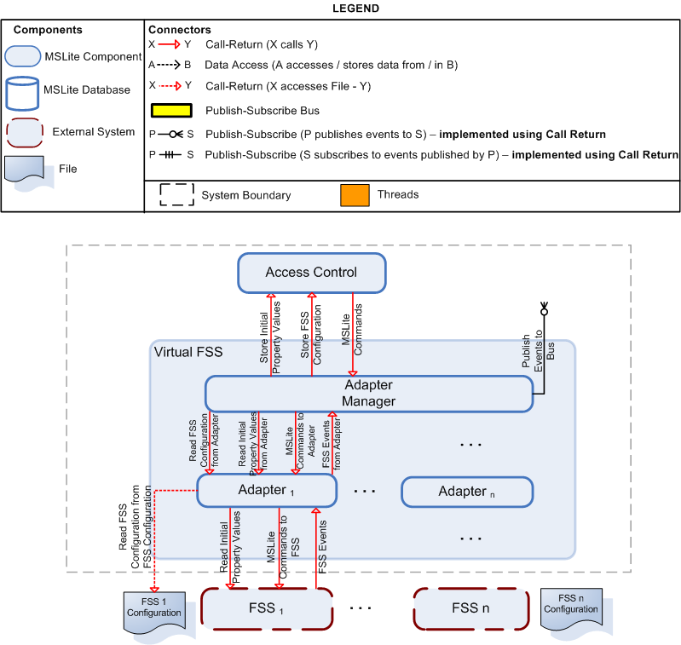
Figure 9: Decomposition of the Virtual FSS

Table 6: Virtual FSS subcomponents
Component | Responsibilities
Adapter Manager | - Receive FSS (COV) events and publish all events to the Publish Subscribe Bus  - Read the FSS Configuration and store it in MSLite database on startup  - Read the initial property values for the FSS and store them in the MSLite cache on startup  - Read the MSLite configuration file to retrieve the Id's for each adapter  - Send MSLite commands to the appropriate FSS Adapters  Note: The Adapter Manager acts as a central component that interfaces communication between the various adapters and the rest of MSLite. The Adapter Manager receives all commands from MSLite and then proceeds to send it to the appropriate Adapter which in turn sends it to the FSS. The Adapter Manager will be responsible for receiving all events and then publishing it to MSLite via the publish-subscribe connector. The Adapter Manager has to keep a list of all the Adapters in order to determine the origin and destination of events or commands. The mapping to an adapter and an FSS is a one-to-one. The Adapter will translate all MSLite commands to the format that FSS can understand and vice-versa. The communication between the Adapter and the FSS is done via a .NET remoting call-return connector.
Adapter | - Translate FSS messages to MSLite messages and vice-versa  - Issue MSLite commands to the FSS  - Send all FSS events to the Adapter Manager  - Read the FSS Configuration and transmit it to the Adapter Manager  - Read the initial property values for the FSS and transmit them to the Adapter Manager

Table 7: Virtual FSS connectors
Connector | Responsibilities
Read FSS Configuration from Adapter | The Adapter Manager reads the FSS Configuration from the Adapter of each FSS
Read Initial Property Values from Adapter | The Adapter Manager reads the initial property values from the Adapter of each FSS
MSLite Commands to Adapter | The Adapter Manager transmits the MSLite commands to the Adapter of the specific FSS for which the command is meant.
FSS Events from Adapter | The Adapter transmits the FSS Events to the Adapter Manager when it receives the FSS (COV) events form the FSS.

C&C View Packet 4: FSS Adapter Component (Configuration Synchronization)
Configuration synchronization is a runtime behavior that is done when MSLite starts executing. In this operating mode, MSLite is making sure that its state information is consistent with the information known about FSSs as described in the configuration file. The internal components of the Adapter are Communicator and Configurator. These are two separate components because they are concerned with different aspects of configuration synchronization. One aspect is to read structural information and the other is to read value information for properties of these structures.
It is important to note that synchronization does not occur more than once during the running time of MSLite. This decision was taken to reduce the complexity of the system. To accommodate constant configuration synchronization (i.e. synchronization after MSLite has started), the following concerns have to be addressed:
- Handle a new adapter for a new FSS
- Frequency of polling configuration file for changes
- Handle existence of property value for a non-existent FSS structure and vice-versa
The Configuration File and the FSS are external to the MSLite system. Call-return connectors were used because of the nature of the data exchange. The File Access connector is a simple I/O connector that reads data from the file. And the call-return connector used between the Communicator and the FSS is done using .NET remoting.
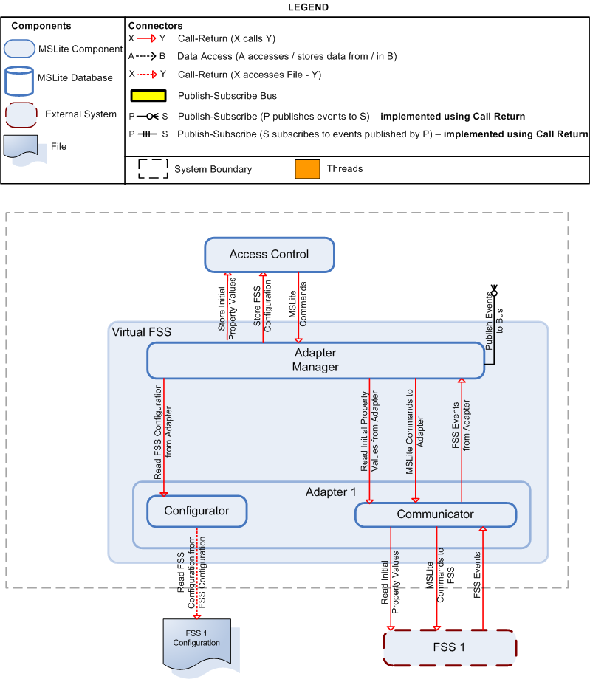
Figure 10: Decomposition of the FSS Adapter

Table 8: FSS Adapter subcomponents
Component | Responsibilities
Configurator | - Read the configuration file and store the information in the database and in the cache.
Communicator | - Read the initial property values of the FSS  - Transmit all MSLite Commands to the FSS  - Receive and publish all FSS (COV) events.

Table 9: FSS Adapter connectors
Connector | Responsibilities
All Connectors | Refer to C&C Level 1.Virtual FSS Connector Catalog.

C&C View Packet 5: Presentation Component
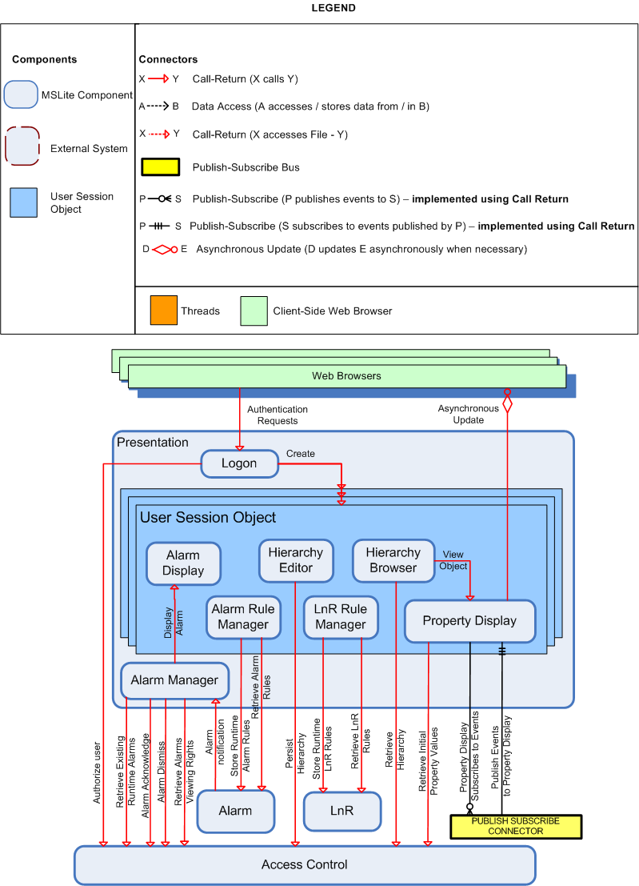
Figure 11: Decomposition of the Presentation component

Table 10: Presentation subcomponents
Component | Responsibilities
Logon | - Authenticates the users login credentials.  - Creates each of the User Session Objects for the individual users' presentation.
Alarm Manager | - Retrieves all those alarms, from the database via access control, that are already existing when the presentation component is instantiated.  - Retrieves the viewing rights of all of these alarms from the database via access control.  - Displays the appropriate alarms in the user sessions that have read access for them.  - Handles each of the notifications of all generated alarms by the Alarm Component.  - Displays the alarms in the appropriate user session.  - Notifies AccessControl about acknowledged/dismissed alarms
Alarm Display | - Displays all of the generated alarms that the particular user has read access to, in the order that they occurred.
Alarm Rule Manager | - Allows the editing of any Alarm Rule that the user has write access to.  - Allows the user to create new Alarm Rules.  - Sends these changes to the Alarm Component.  - Allows the management of Alarm Rules
Hierarchy Browser | - Shows the Hierarchy of Field Objects that has been selected for viewing by the user.  - The hierarchy can be traversed by the user by selecting the different nodes to expand or contract.
Hierarchy Editor | - Allows the editing an existing Hierarchy that the user has write access to.  - Allows the user to create a new Hierarchy that can be viewed in the Hierarchy Browser.  - Sends these changes to the Database via the Access Control.
LnR Rule Manager | - Allows the editing of any Logic and Reaction Rule (LnR Rule) that the user has write access to.  - Allows the user to create new LnR Rules.  - Sends these changes to the LnR Component.  - Allows the management of LnR Rules
Property Display | Once the user has selected the property of field object to be displayed:  - Retrieves the initial property value from the access control.  - Subscribes the user to events generated for the particular property.  - Handles all events published to the PublishSubscribe Component relating to this property.  - Displays received change of values for the property.

Table 11: Presentation connectors
Connector | Responsibilities
Authentication Requests | The Web Browser sends the User's Logon Credentials to the Logon Component for Authentication.
Authorize User | Logon retrieves the user's details from the database via the access control so as to facilitate the authentication.
Create | Logon creates a unique User Session Object for each of the users as they log into the MSLite Server.
Retrieve Existing Runtime Alarms | The Alarm Manager retrieves the details of existing alarms that are persisted in the MSLite Database via the Access Control.
Retrieve Alarms Viewing Rights | The Alarm Manager retrieves the users' access rights of all alarms present in the system at runtime via the Access Control.
Display Alarm | The Alarm Manager sends the Alarm details to the Alarm Display of the User Session Object for the users that have read access for it.
Alarm Acknowledge | The Alarm Manager notifies the AccessControl about acknowledged alarms.
Alarm Dismiss | The Alarm Manager requests the AccessControl the dismissing of an already acknowledged alarm.
Alarm Notification | The Alarm Component sends notification of each alarm to the Alarm Manager once they are generated.
Store Runtime Alarm Rules | The Alarm Rule sends the Updated or New Alarm Rules to the Alarm Component which looks after all of their handling issues (e.g. persistence in the database).
Retrieve Alarm Rules | Alarm Rule retrieves the Alarm rules from the database
Retrieve Hierarchy | The Hierarchy Browser retrieves the details of the Hierarchy, which the user has chosen to view, from the Database via the Access Control.
Persist Hierarchy | The Hierarchy Editor sends the Updated or New Hierarchy to the Access Control that will handle its persistence in the Database.
Store Runtime LnR Rules | The LnR Rule Editor sends the Updated or New LnR Rules to the LnR Component which looks after all of their handling issues (e.g. persistence in the database).
Retrieve LnR Rules | LnR Rule Editor retrieves the LnR rules from the database
View Object | The Hierarchy Browser sends the Property ID, of the Property that the user has chosen to view, to the Property Display.
Retrieve Initial Property Values | The Property Display retrieves the initial property value for the Field Object Property that is to be displayed from the Access Control, which has been received from the relevant FSS and stored in the Value Cache.
Property Display Subscribe to Events | The Property Display subscribes to events from the FSS for the Property ID of the property it is displaying.
Publish Events to Property Display | The PublishSubscribe publishes events generated by the FSS for the Property ID of the property that the Property Display is subscribed to.
Asynchronous Update | The Property Display asynchronously updates the Web Browser with any new property values when they are received as published events from the PublishSubscribe.

C&C View Packet 6: Alarm Component
The Rule Processor and Alarm Processor are the two components that make up the Alarm component.
Three important differences between this detailed view and the high-level view in view packet 1 are:
- In this view, there are two call-return connectors where the Presentation is the caller. However, in the high-level view, there is only one connector. Hence, the two connectors shown here make up the single call-return connector in the High-Level view.
- In this view, there are multiple call-return connectors from the Rule and Alarm processor to the Repository. However, in the high-level view, there is only one. Hence, these multiple call-return connectors make up the single connector in the high-level view.
- In this view, there is an extra subscribe connector but not in the high-level view. These two subscriptions form the single subscribe connector in the high-level view. This extra connector is to support the extensibility scenario whereby alarms will be originating from an external source.
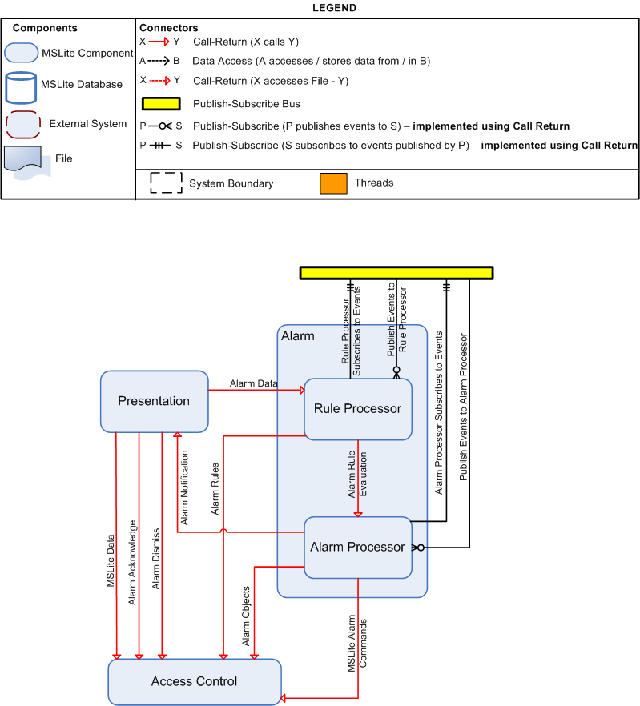
Figure 12: Decomposition of the Alarm component

Table 12: Alarm subcomponents
Component | Responsibilities
Rule Processor | - Subscribe to receive COV events  - Evaluate the alarm rules based on COV events against property values in the cache and the alarm rules  - Forward alarm rule information (if alarm condition evaluates to true) to Alarm Processor to generate alarm  Note: The Alarm Processor and Rule Processor components are separate components mainly because determining whether an alarm should be created is different from actually creating an alarm and the functionality of each of these actions can be cleanly separated.  The Rule Processor deals with all the alarm rules – it registers for COV events, and executes the rules.  The Rule Processor needs to know only about the conditions and actions that should be done based on the condition evaluation. The Rule Processor does not need to be concerned with actually creating alarms. It is only concerned with making sure that it makes the correct evaluation based on the conditions it knows of.  Because of the clean separation in functionality displayed here, these two components were split. This makes the design more extensible even though extensibility with a concern for alarm functionality was not an explicit quality attribute.
Alarm Processor | - Generate alarm objects  - Notify Presentation of new alarm objects.  - Future extension: Subscribe to receive Alarm events  - Future extension: Issue commands to the FSS for dismissing or acknowledging alarms  Note: The Alarm Processor and Rule Processor components are separate components mainly because determining whether an alarm should be created is different from actually creating an alarm and the functionality of each of these actions can be cleanly separated.  The Alarm Processor handles all processing that deals with runtime alarm objects in MSLite. This includes generating alarms and issuing the appropriate commands to the Virtual FSS based on the user's context  The Alarm Processor is concerned with actually doing something with the information it gets from the Rule Processor.  Because of the clean separation in functionality displayed here, these two components were split. This makes the design more extensible even though extensibility with a concern for alarm functionality was not an explicit quality attribute.

Table 13: Alarm connectors
Connector | Responsibilities
Rule Processor Subscribes to Events | The Rule Processor subscribes to COV Events
Publish Events to Rule Processor | The Publish Subscribe Connector publishes events to the Rule Processor
Alarm Processor Subscribes to Events | The Alarm Processor subscribes to COV Events
Publish Events to Alarm Processor | The Publish Subscribe Connector publishes events to the Alarm Processor
Alarm Rule Information | When an alarm evaluates to true the Alarm Process must be informed so that is can generate an alarm in the system. This connector is responsible for informing the Alarm Processor and passing on all relevant information about the alarm to be generated.

Process View
The Process View shown in Figure 13 is the runtime representation of MSLite and its processes.
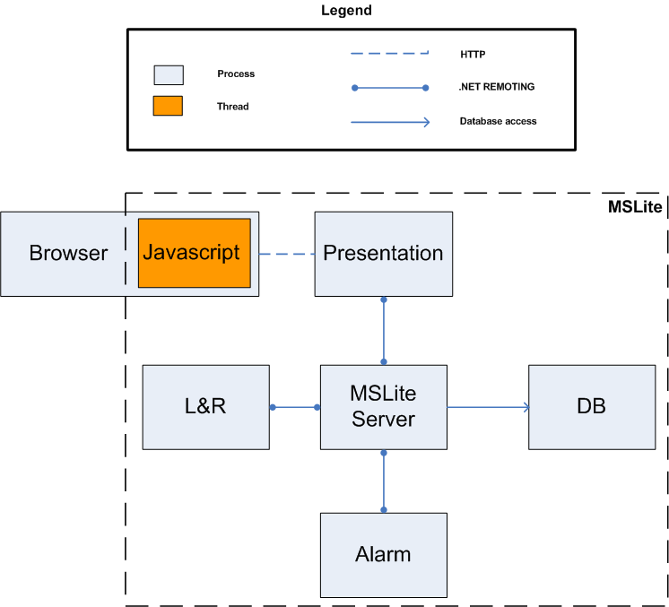
Figure 13: Process view

Table 14: Process view elements
Component | Description
Browser | This process represents the client's browser used to access the MSLite system
JavaScript | This thread is responsible for executing MSLite client-side JavaScript code that the MSLite system will call. E.g. new alarm and property values notification.  Important: The performance quality attribute of MSLite requires that the user interface be updated with alarm information within 3 seconds of the alarm occurring. To accommodate this requirement, asynchronous updates of the client-side have to be done. Callbacks from the server are embedded in the client side and handled using JavaScript so that the relevant elements of the client-side DOM can be updated to provide asynchronously updated data.
Presentation | This process is responsible for storing the webpage files as well as other client-side resources
L&R | This process is responsible for executing L&R rules and commands independently of the MSLite server. It acts upon receiving COV events from the FSS. It also helps the presentation add, edit and delete L&R rules.  Important: It was decided to have L&R and Alarm execute in their own process and as such this needed to be communicated clearly. This is done by having individual processes for these components. Both Alarm and L&R components gain the following advantages when they are able to execute as separate processes in MSLite:  - It is easier to test and support the independent development.  - Run-time integration of the components is made easier as long as they obey the interfaces to which they are bound.
Alarm | This process is responsible for executing Alarm rules and generation of alarm objects. It acts upon receiving Alarm and COV events from the FSS. It also helps the presentation add, edit and delete Alarm rules.  Important: It was decided to have L&R and Alarm execute in their own process and as such this needed to be communicated clearly. This is done by having individual processes for these components. Both Alarm and L&R components gain the following advantages when they are able to execute as separate processes in MSLite:  - It is easier to test and support the independent development.  - Run-time integration of the components is made easier as long as they obey the interfaces to which they are bound.
MSLite Server | This process is responsible for the core functionality of the MSLite system. It acts as an intermediate to allow communication between the different processes
Database | This process is required to run the MSLite database

Table 15: Process view relations
Connector | Description
.NET remoting | The .NET framework provides .NET remoting to allow objects living in different processes to communicate with each other. This was a natural fit for the MSLite architecture as several processes are involved with its operation and communication is necessary between the different process as shown in the process view.
HTTP | For communication between the web client and MSLite running on application servers, the normal web protocol of HTTP is used.

Module Views
This section documents the implementation units of MSLite and how they depend on each other. The diagrams use UML 1.5 packages to depict modules. Two kinds of dependencies are included:
- a uses dependency between two modules A and B means that A cannot function correctly without a correct implementation of module B
- a regular dependency between modules A and B means that A calls B.
For illustration purposes we can examine the two following examples:
- The Adapter Manager has a regular dependency towards the Publish-Subscribe module because it publishes COVs on the Publish-Subscribe bus. However, if the Publish-Subscribe bus has a faulty implementation and fails to deliver the COVs, this doesn't affect the Adapter Manger's fulfillment of its requirements.
- On the other hand the Logon has a uses dependency towards the Data Access module. That is, if the latter doesn't function properly, the Logon module cannot do proper authentication and therefore cannot fulfill its requirements.

Module View Packet 1: MSLite
This section contains the high-level decomposition of MSLite into modules. A module is an implementation unit of software that provides a coherent unit of functionality.
At this level of granularity we only show general dependencies between modules. If a module A depends on another module B, the developer of A needs information about how to access B at development time. Module interfaces are specified in the reference manual.
The decomposition in this view is motivated mainly by the following two goals:
- Create modules that implement a consistent unit of functionality.
- Constrain the use of certain technologies to one module wherever possible.
The second goal is based on the assumption that the development teams have little previous experience in the proposed implementation technologies. When only one module uses a technology, only teams directly involved in the development of this module need to spend time learning it. However, the Presentation module may be too big to be developed by a single team.
The module view contains unidirectional dependencies that do not form cycles. This is achieved by implementing some call-return connectors as callbacks. It was done for:
- notifications from the FSS Adapter to the Adapter Manager,
- event notifications from Publish-Subscribe to event subscribers, and
- alarm status change notifications from Rules to Presentation.
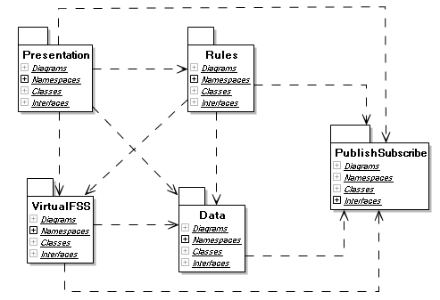
Figure 14: Module decomposition of the MSLite system

Table 16: MSLite system modules
Module | Responsibilities | Implementation Information
Presentation | Hide details of user interaction:  - Manage user interaction with MSLite, such as editing hierarchies, acknowledging alarms, displaying field object properties, etc. | The presentation module uses AJAX to asynchronously update the user interface.
Rules | - Create, Update and Delete L&R rules  - Create, Update and Delete Alarm rules  - Execute L&R rules and issue L&R commands  - Execute alarm rules and generate alarms  - Facilitate Alarm acknowledgement  - Future Extension - Issue Alarm Commands
Publish Subscribe | Hide details of event delivery:  - Allow other modules to publish events (COV and alarm)  - Allow other modules to subscribe to events  - Allow other modules to unsubscribe from events  - Deliver published events to all subscribers
Adapter Manager | Hide the fact that there are (potentially) many FSSs connected to MSLite:  - Direct commands to the correct FSS adapter  - Receive COV notifications from all FSS adapters and publish the corresponding MSLite COV events to the Publish Subscribe Bus  - Coordinate configuration of MSLite according to individual FSS configurations (including reading their initial property values).
Data | Hide details of how data is persisted and accessed:  - Manage all persistent data in MSLite and all data in the cache  - Control access to data  - Maintain consistent snapshots of property values | The data module uses NHibernate to implement the mapping between objects in memory and tables in the database.
FSS Adapter | Hide details of configuration of and communication with an FSS:  - Translate commands between MSLite and FSS  - Translate COV notifications between FSS and MSLite  - Read configuration data for a single FSS (including reading their initial property values)  - Future Extension: Translate alarm notifications between FSS and MSLite | The adapter is specific to the kind of FSS.

Table 17: MSLite system module dependencies
Module | Depends on | Dependency used to
Adapter Manager | Data | Store FSS configuration data and initial property values
Adapter Manager | FSS Adapter | Retrieve configuration data, send commands, register callbacks for COV (and later alarm)notifications, register callback for COV failure notification
Adapter Manager | Publish Subscribe | Publish COV events, COV failure events, and later alarm events
Data | Publish Subscribe | Subscribe to COV events
Presentation | Adapter Manager | Send user commands
Presentation | Data | Access hierarchies, property values, rules
Presentation | Publish Subscribe | Subscribe to COV events and COV failure events
Presentation | Rules | Send notifications if the user adds, deletes, or changes rules, acknowledge alarms, register callbacks for new alarms and alarm status changes
Rules | Adapter Manager | Send commands based on rule executions, send alarms status change commands
Rules | Data | Access rules, alarms, and property values. Send alarm acknowledgement
Rules | Publish Subscribe | Subscribe to COV events and alarm events

Module View Packet 2: Presentation
The presentation module for MSLite is focused mainly on the user interface functionality for MSLite. The presentation module was created to accommodate the functional requirement and the constraint that MSLite be run as a web based application. MSLite needs to display information from the FSS to its end-users and also allow those end-users to create L&R rules, logon to the software system, and view and manipulate alarms. A sub-module was created for each of these packages as the functionality they provide is independent of each other. Presentation sub-modules are shown in Figure 15 along with their external dependencies.
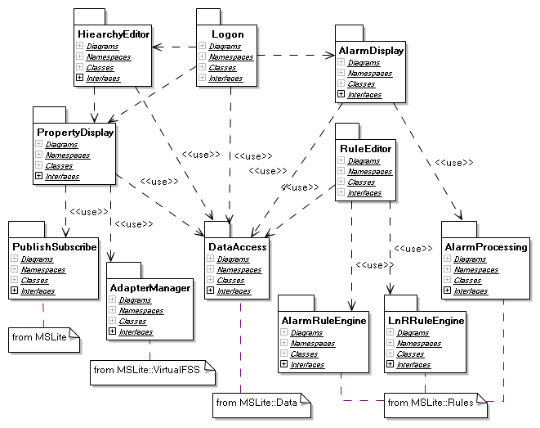
Figure 15: Decomposition of the Presentation module
Each presentation module includes ASP.net Web pages, C#-code that executes on the Web server in the Presentation process, and JavaScript code that executes on the client.

Table 18: Sub-modules of the Presentation module
Module | Responsibilities | Implementation Information | Comments
Hierarchy Editor & Display | - Retrieve hierarchy information  - Display hierarchies to the user  - Allow user to select a hierarchy and browse  - Allow user to edit hierarchical structures | - Trigger Property Display if the user selects a field object in the hierarchy  - Use Data::Data Access to retrieve and update hierarchies  - All data access is done using the interface provided by the Data::Data Access module. | We assume that editing hierarchies and displaying hierarchies for browsing can potentially share some code.
Property Display | - Display properties and their values of a field object (from the cache)  - Update UI as soon as a property value changes  - Allow editing of changeable property values (this is the issue command functionality) | - Send commands to Adapter Manager and displays the result of the command execution.  - Use Data::Data Access to retrieve a list of properties for a field object the list will indicate if a user has read or write access to a property.  - Each user must have an event handler to receive COV events.  - All data access is done using the interface provided by the Data::Data Access module.
Logon | - Provide a logon screen  - Initialize other presentation modules after successful logon  - Store and maintain user sessions and pertinent session information  - Provide logoff functionality | - Each user will have its own session.
Alarm Display | - Retrieve alarm information from the database  - Display current alarms  - Update UI as soon as a new alarm occurs  - Allow user to acknowledge alarms  - Allow user to dismiss alarms  - Display alarm list to user  - Immediately update other user's UIs as soon a user acknowledges or dismisses an alarm. | - There is one shared handler for alarm notifications.  - Avoid using popup windows to notify the users that a new alarm has been created.  - All data access is done using the interface provided by the Data::Data Access module. | Popups windows do not fulfill the handle alarms requirement - any user viewing an “Alarm Acknowledgment Request” can acknowledge it. After an user has acknowledged the alarm, the request should be removed from all users' screen. The use of popup windows does not allow removing the rest of the acknowledgement requests.
Rule Editor | - Allow user to edit alarm rules and update them accordingly  - Allow user to edit L&R rules and update them accordingly | - Use Data::Data Access to retrieve rules from the database.  - Use Rules::Alarm Rule Engine and Rules::L&R Rules Engine to update Alarm and L&R rules | Rule editors should share code to edit the condition part of a rule.

Module View Packet 3: Rules
A rule consists of two parts, namely condition and action. Alarm and L&R rules are the two types of rules in MSLite. The condition part of these two types of rules is the same; hence, the logic to evaluate a condition is the same and is implemented within the Condition Evaluation sub-module. This sub-module is used by both rules engines, Alarm and L&R.
The L&R Rules Engine issues a command to the Adapter Manager whenever a L&R rule condition evaluates to true.
The Alarm Rules Engine notifies the Alarm Processing that the condition for creating an alarm is met. Then, Alarm Processing will create a new alarm, publish it, and handle its lifecycle. To accommodate the modifiability scenario for future iterations, the Alarm Processing sub-module will also subscribe to alarm events created by the extended FSS through Publish Subscribe. By then, Alarm Processing will create an alarm whenever it is created in the extended FSS. This new type of alarms will be handled as any other alarm created within MSLite. When an alarm is acknowledged, Alarm Processing will notify the Adapter Manager to change the alarm status in the extended FSS.
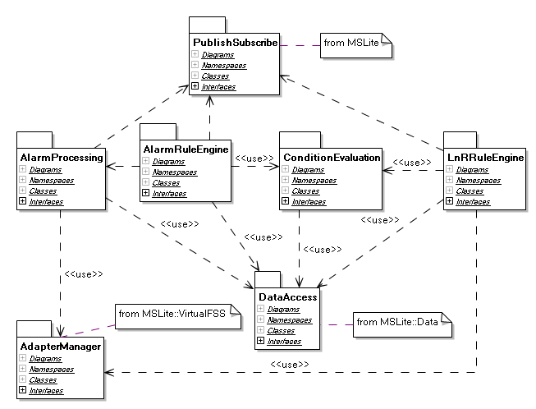
Figure 16: Decomposition of the Rules module

Table 19: Sub-modules of the Rules module
Module | Responsibilities | Implementation Information | Comments
Alarm Rule Engine | - Store alarm rules  - Execute alarm rules, triggered by COV message  - Notify Alarm Processing that a new alarm has to be created
L&R Rule Engine | - Store L&R rules  - Execute L&R rules, triggered by COV message
Condition Evaluation | - Evaluate Alarm & L&R rule conditions based on COV messages (and instructions received by the Alarm and L&R Engines respectively) and current property values - These checks will be made by comparing property values in the cache and the rules in the cache (and not the database) for performance reasons | These checks will be made by comparing property values in the cache and the rules in the cache (and not the database) for performance reasons | This module represents code shared between the Alarm and L&R rule engines.
Alarm Processing | - Create alarms  - Handle alarm lifecycles (including alarm acknowledgement)  - Publish alarms  - Persist all alarms in the database.  - Future Extensions:  - Subscribe to alarm events from extended FSS through Publish Subscribe  - Notify Adapter Manager when an alarm has been acknowledged  - Issue Alarm Commands to the Adapter Manager

Module View Packet 4: Publish Subscribe
The Publish Subscribe module contains functionality that allows events to be propagated from the FSS to MSLite. The realization of the Buffer Receiver, Subscription Manager, Coordinator, and Event Publisher are all contained in this module. An assumption made is that it is safe for a subscriber to subscribe to an event when there is no publisher for such an event and vice-versa. The publish subscribe mechanism that will be implemented in this module will use structures that define Events. An event structure provides several pieces of information which we discuss here.

Event Structure
- Event definition
  - Fixed event vocabulary. There are three fixed types of events defined for MSLite. COV events provide information on a change of property value that occurs in a FSS. An NCOV event provides error state information for circumstances when a command is issued to the FSS but the command was not actually executed. An Alarm event is also defined to accommodate the modifiability concern related to the support for an extended FSS.
- Event structure
  - Parameters. Each event will have a unique identifier and a set of parameters containing information about the event. The number of parameters is fixed and contains information specific to the event.
- Event bindings
  - Dynamic event bindings. Components within MSLite are allowed to subscribe and unsubscribe to events at runtime. Because of this, events will need to be bound to components dynamically.
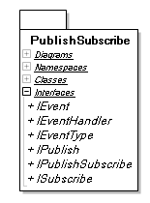
Figure 17: Publish-subscribe module

Table 20: Publish-subscribe module responsibilities
Module | Responsibilities | Implementation Information | Comments
Publish Subscribe | - Allow components to subscribe and unsubscribe to events  - Buffer events from FSS

Module View Packet 5: Virtual FSS
To accommodate the modifiability scenarios, the Virtual FSS was incorporated in the architecture to allow the addition and replacement of FSS without requiring changes in MSLite. The Virtual FSS contains two modules: The Adapter Manager and the FFS Adapter
Each FSS interacts with the Adapter Manager through an FSS Adapter. There is one FSS Adapter for each FSS.
The Adapter Manager has a configuration file that contains all the information of FSS Adapters that are expected to interact with the MSLite system. The rationale for having a configuration file is to avoid changes in the Adapter Manager module for each addition or replacement of FSS Adapters. The Adapter Manager will read its configuration file each time the system is restarted to register the FSS Adapters. If there is a new FSS Adapter, it has to be added in the configuration file and the MSLite system must be restarted in order to recognize the new FSS Adapter.
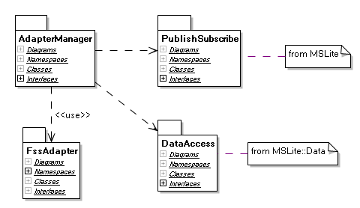
Figure 18: Decomposition of the Virtual FSS module

Table 21: Sub-modules of Virtual FSS and their responsibilities
Module | Responsibilities | Implementation Information
Adapter Manager | - Direct commands to the correct FSS adapter  - Receive COV notifications from all FSS adapters and publish the corresponding MSLite COV events to Publish Subscribe  - Coordinate configuration of MSLite according to individual FSS configurations | - The Adapter Manager knows about the FSS Adapters because of the configuration file. This configuration file has the name of the main class, dll name, and identification number of each adapter.  - The Adapter Manager will instantiate FSS Adapters using the name of the main class stored in the configuration file. No recompilation should be needed for the Adapter Manager to incorporate or replace FSS Adapters.  - The identification number must be a unique number within the configuration file. This number is stored in the internal_id field from the ObjetcID class of the Base Package in the Domain Model. This mechanism serves to identify to which FSS an object, such as field objet and property value, belongs to. Each FSS maintains its own identification numbers which can be stored in the external_id field of the ObjectID class. The internal_id and external_id form a unique pair of identifiers that the Adapter Manager uses to send and retrieve information from FSS Adapters.

Module View Packet 6: Adapter
For each FSS there will be an Adapter to accommodate the functionality and interaction with an FSS, such as translate commands, COVs, and alarm events from the corresponding FSS to MSLite and vice versa. Although there will be an Adapter for every FSS, all the Adapters interact with the Adapter Manager; hence, they have a common back-end to allow for this communication.
When designing this module for the first time, the team has to think of a class template that has the back-end to interact with the Adapter Manager. This template should be reused when creating a new Adapter. In this way, all the FSS Adapters will have the same back-end and a different front-end specific to a particular FSS.
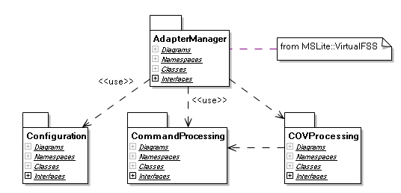
Figure 19: Decomposition view of the Adapter

Table 22: Adapter sub-modules
Module | Responsibilities | Implementation Information | Comments
Configuration | - Create or update MSLite configuration based on FSS configuration data  - Read initial set of values at system start up time | The configuration data for each FSS is provided in a FSS Configuration XML file.
Command Processing | - Receive MSLite commands  - Translate from MSLite commands to FSS commands  - Execute FSS commands  - Detect failure of FSS to change a value as required by a command and send MSLite NCOV events
COV Processing | - Translate from FSS COV event to MSLite COV notification  - Notify Adapter Manager to publish MSLite COV notification

Module View Packet 7: Data
The purpose of the Value Cache is to maintain the property values in memory and give a snapshot of these values at the time an event is generated. That is, the Value Cache keeps a copy of value of the properties in the FSS, and updates the values one by one per COV event.
The Rules::Condition Evaluation sub-module reads the property values in the Value Cache indirectly when evaluating the condition of a rule. This is done indirectly because Value Cache can only be accessed through Data Access which checks the permission first. For example, there is an L&R rule that triggers an action when property A is 4, and property B is 2. The initial value of A and B is 2. These two properties changed almost at the same time in the FSS. Property A changed to 4, and later B changed to 1. As a consequence, two COV events are generated within MSLite but they are handled one by one in the order they happened. L&R Rule Engine is notified that property A changed to 4 and checks for the value of B at the time A changed by reading the Value Cache. The value of B in the Value Cache is still 2 because it is a snapshot of all property values when A changed. Hence, L&R Rule Engine triggers the action because the condition of that rule is met.
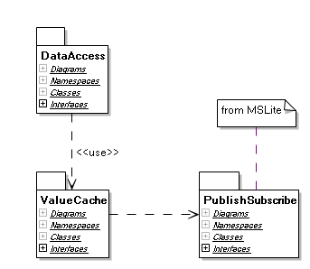
Figure 20: Decomposition of Data

Table 23: Data sub-modules
Module | Responsibilities | Implementation Information | Comments
Data Access | - Check if a user is an authorized user within MSLite for login purposes  - Maintain list of currently logged on users and assign an authorization token to each user  - Allow other modules to check what kind of access a user has to a certain data element  - Allow users to retrieve data they have access to from the database and from the cache  - Persist data in the database  - Store and update the data in the cache | - A system token is used by the L&R and Alarm components to indicate that no permission is required to access the information  - The data types that are used in the Data Access are according to the Field Objects and Object Types packages found in the domain model. | NHibernate is used as a .NET based object persistence library for relational databases.
Value Cache | - Store all property values  - Update values based on COV messages

Deployment View
The Deployment view shows the different components of MSLite and how they are distributed across different machines. It also describes how each component in a machine will interact with other components in their respective machines.
The deployment diagram shown is not the only option that is available in deploying the MSLite system. There are other scenarios such as:
- FSS being deployed on a separate machine
- Presentation being deployed on a separate machine
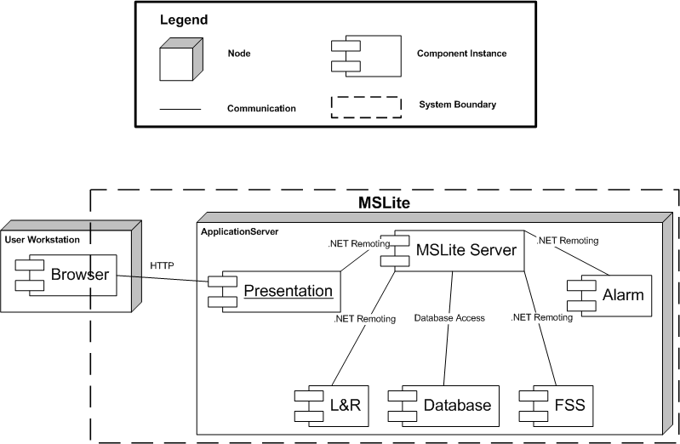
Figure 21: Deployment of MSLite components

Table 24: Deployment view element catalog
Element | Description
Client Browser | - There will be some MSLite code in the form of JavaScript in the browser and hence, the system boundary of MSLite includes some portion of the user's workstation browser
Presentation | - This contains one or more .NET assemblies for the webpage and other client-side resources  - These assemblies will be executed in the context of the Application Server in a dedicated ASP.NET process  - It will communicate with the MSLite Server subsystem by means of .NET remoting
MSLite Server | - This subsystem will be executed in a .NET executable as a separate process  - This is the main subsystem that acts as a middle subsystem | Database
Alarm | - The Alarm executable will also be executed as a separate process in MSLite  - It will communicate with the MSLite server and the database for rule operations as well as managing the lifecycle of an alarm object  - Future extension: It will issue Alarm Commands to the FSS through the MSLite Server
L&R | - The L&R executable will also be executed as a separate process in MSLite  - It will communicate with the MSLite server and the database for rule operations.  - It will issue L&R Commands to the FSS through the MSLite Server
Database | - There will be a MySQL database which is accessible to the MSLite Server subsystem  - Other subsystems like L&R and Alarm will access the database through the MSLite Server.
FSS | - The MSLite system will interact with the FSS system by means of .NET remoting

Project Layout View
This architectural view of MSLite focuses on the file-system used by developers of the project. This file system contains elements that represent directories and relationships that represent a parent-child relationship between directories. Child elements are sub-directories contained within the parent directory.

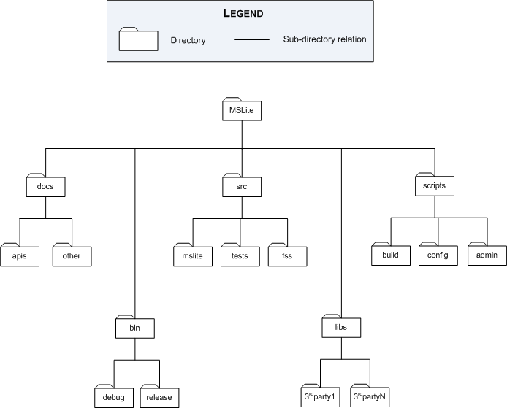

Figure 22: Structure of the MSLite file system

Table 25: File system element catalog
Name | Responsibilities | Comments
MSLite | Top-level directory that contains all files and folders with information concerning MSLite project
doc | Contains code-level documentation created by stakeholders (i.e. developers, architects, managers)
apis | Contains generated API documentation from .NET projects | This directory is to be referenced from the .NET projects created for MSLite
other | Contains miscellaneous documentation that cannot be categorized as API documentation
bin | Contains binaries generated from the compilation of the .NET projects along with any other binaries necessary for software system execution | All .NET projects will have this directory as the output directory
debug | Contains debug version of binaries generated from compile of projects
release | Contains release version of binaries generated from compile of projects
src | Contains C# source code for all projects created for MSLite | Projects will live in sub-directories within this folder
core | Contains C# source code that constitutes the core set of functionality for MSLite
tests | Contains C# source code that is used to unit test projects for MSLite | The output of these unit tests is the MSLite/bin directory
fss | Contains C# source code for the Field System Simulator (FSS) | Since this application is external to the MSLite system boundary, its source is kept separate from MSLite's core
libs | Contains source code and documentation for third-party libraries used during the development of MSLite | Any projects that use these third-party libraries must reference them using this directory
3rdparty 1 .. n | Contains source code and documentation for a particular third-party library | Each third-party library is stored in its own sub-directory of the MSLite/libs directory
scripts | Contains scripts used to build MSLite, configure the environment, or perform administrative tasks for MSLite
build | Contains build scripts for MSLite project
config | Contains configuration scripts for MSLite
admin | Contains administration scripts for MSLite

Binary output directory
The MSLite/bin folder is the target folder for all output from compilation. The reason for this structure is that it allows all the different distributed projects to have a common area for execution. If each project had its own output folder, developers would have to copy files across projects to get a running executable. This cross copying of files would be necessary because of the dependencies that exist between modules in MSLite. If there were no dependencies between modules, then each project could run independent of each other and contain their own output folder.

Source directory
The MSLite/src folder contains all source code written for MSLite. The sub-directories of this folder contain the individual projects that contain the implementation for the various modules of MSLite. Folder names for projects reflect the namespace structure used for the MSLite modules. The reason for this structure is that it immediately allows a developer to understand the structure of the software system by directly seeing a one-one mapping of modules to file structure. When a developer needs to know where to find code for a module they depend on, they are immediately given a clue by looking on the file structure. A caveat with this structure however, is that the file structure names can become verbose depending on the naming scheme used for namespaces.
The source folder also contains a tests sub-directory. This directory contains unit tests for the MSLite modules. The structure of this sub-directory reflects the structure of the core and fss directories. The reason for this is that unit tests are self-contained and should be specific to a module.

MSLite module projects
The modules identified in the module views of MSLite will be implemented in .NET based projects. Each module will have functionality that exists in namespaces that reflect the logical structure from the module view. Each project lives within a folder whose name is the namespace containing the module structure. The top level namespaces are as follows:
- mslite
- fss
- mslite.tests.core
- mslite.tests.fss
The two top-level namespaces for MSLite are mslite and fss because the FSS is external to the MSLite system boundary. The functionality of the FSS can be implemented completely independently of the MSLite and its core modules. However, the MSLite core modules have a tighter coupling to the FSS as it uses information from the FSS. Because this dependency is not bi-directional, there can be two separate top-level namespaces to logically organize the development of these systems.
The namespaces identified based on the module view of MSLite are:
- mslite.adaptermanager
- mslite.data
- mslite.fssadapter
- mslite.presentation
- mslite.publishsubscribe
- mslite.rules
As an example of a file system layout, we can view the file structure when the modules of MSLite are created on a file system using the Microsoft Windows operating system:
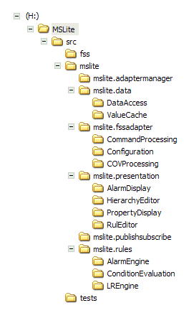

Project references
The file structure in this view allows the MSLite project structure to be portable. The top-level MSLite directory acts as a starting point for referencing material within the project space. All projects, scripts, and binary references must use relative paths. The use of relative paths allows the MSLite project structure to be distributable in the sense that the entire project structure can be transferred to different machines without the need for reconfiguring references throughout the project. If absolute paths were used for file and folder references, then the absolute path would have to be mirrored on any file system that the project is transferred to.

Assumptions
Assumptions made during the discussion of the architecture background are mainly concerned with the development teams tasked with building the MSLite software system. The development teams are assumed to:
- Have access to a central version controlled repository provided by Siemens to do their development
- Be comfortable with using the Microsoft Visual Studio.NET 2003 IDE for development and know how to change project settings.
- Be aware of their assigned modules from the MSLite architecture.
- Be familiar with the MSLite Code Integration process and the MSLite Change Control process provided by Siemens.
- Be familiar with constructing and using unit tests.

Behavioral Specification
This section documents how the proposed architecture fulfills the functional requirements. UML 1.5 sequence diagrams have been used to document the behavior using elements from the module views (see Section 5.3). The method calls shown in the diagrams are methods in the interfaces of the respective modules.
Notes:
- Some sequence diagrams show interactions between FSS Adapter submodules and the FSS, but note that the details of these interactions are FSS specific.
- User interactions are indicated by pseudo method calls or textual description, e.g, viewObject(fieldObjectID) may indicate that the user has selected a field object on the UI and then clicked on a button to display this field object.

Logon
A user provides username and password as credentials. If the credentials are valid the Data Access module adds the user to a list of logged on users and assigns the user a unique token. This token is used during further operation to check permissions. The presentation module stores the token for the lifetime of a user's session.
A user may be logged on in several sessions simultaneously. This behavior is necessary to handle the case where a user closes the browser without logging out of MSLite. When the session associated with the closed browser times out the presentation module logs the user out automatically.
If a user logs on to MSLite the system performs the following initialization operations
- Display all hierarchies of the user
- Restore the state of the object browser
- Restore the state of the work area
- Subscribe to events for currently displayed properties
- Show alarms currently in the system that the user can acknowledge
The Presentation module uses preference values to store all information needed to restore the user interface state.
The Presentation module provides an individual event handler object for each user logged on to the system.
To display the property values in the work area correctly the Property Display module must access the field object template and instance to get metadata that is used to create the user interface components for the field object properties. For example, if the property value is a string with a number of allowed values the user interface should display a component that allows the user to select one of the values. The allowed values are stored in the in the field object template.
Figure 23 shows the sequence of operations performed during Logon.
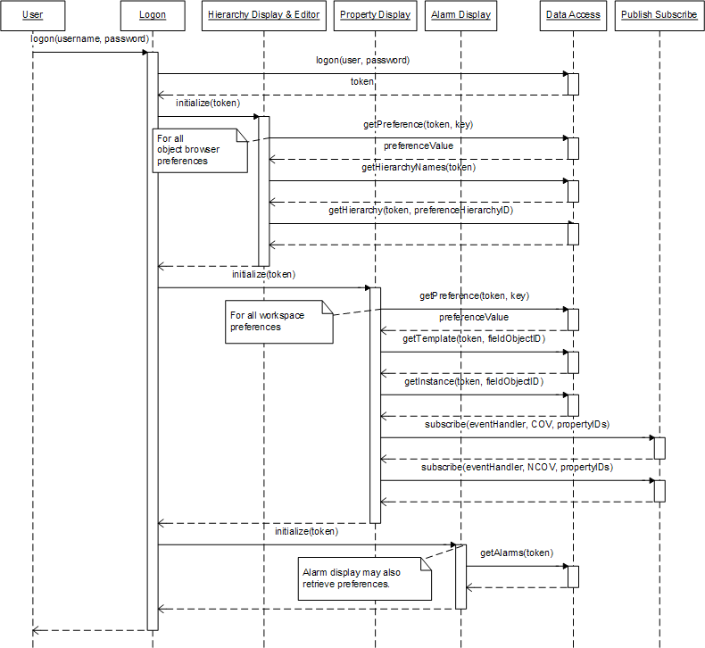
Figure 23: Logon sequence diagram

Logoff
When a user logs off, the Presentation module stores hierarchy and property display state as necessary. The preference key-value pairs to store this information are to be defined in the Presentation submodules.
In addition, Property Display unsubscribes the user's event handler from all events.
Finally, Data Access removes the user from the list of logged on users, thus invalidating the token.
Figure 23 shows the sequence of operations performed during Logoff.
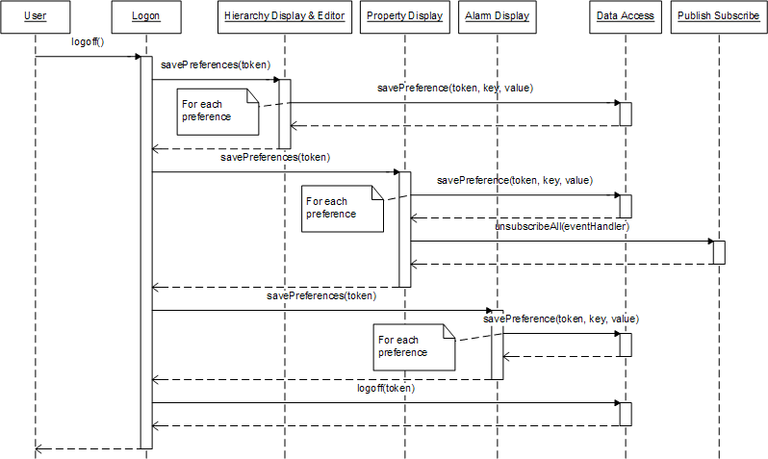
Figure 24: Logoff sequence diagram

Editing a Hierarchy
Here we assume a simple case where a user selects a hierarchy for editing from the list of their hierarchies. Once the user selects a hierarchy the editor displays the current hierarchy and a list of all field objects the user has access to. There is no need to lock a hierarchy during editing because only one user - the hierarchy owner - has access to any given hierarchy.
Figure 25 shows the sequence of operations performed during editing a hierarchy.
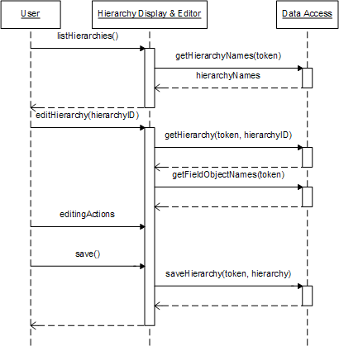
Figure 25: Sequence diagram for editing a hierarchy

View Properties
Displaying the properties and property values of a field object is initiated when the user selects a field object in a hierarchical view in the object browser. Property Display then updates event subscriptions for the user's session and reads property type data and current values from the repository. COV and NCOV subscriptions are for the same set of properties.
Property type information is retrieved in the field object template data structure and current values are retrieved in the field object instance data structure. Property Display creates UI elements based on the property type information. The object template also contains access permissions for this user for each property in the field object.
Figure 26 shows the sequence of operations performed during the viewing of properties.
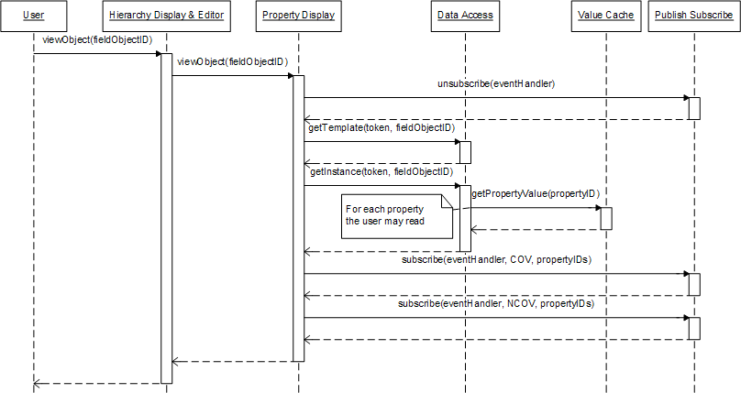
Figure 26: Sequence diagram for editing a hierarchy

Issue Command
This sequence starts with a user issuing a command to change a property value. There is no need to check if the user has write access to the property because the UI evaluates the user's access rights and enables editing only for those properties the user is actually allowed to change. The adapter manager forwards the command to the correct adapter. It does this by evaluating the property ID and maps the ID to the appropriate adapter. The Command Processing sub-module in the adapter sends the command to the FSS using the simulator's protocol.
After the value has changed the adapter manager creates an MSLite COV event from the COV notification and publishes that event.
Depending on the FSS there are several options how the adapter can detect if a value change command is successful or not:
- The FSS responds with a change notification after the command has been executed successfully and does nothing if the command fails. This is the case shown in the previous diagram. It is the responsibility of Command Processing to match COV notifications and commands. The only way to detect failures is to implement a timeout mechanism that detects if there is no matching COV notification for a command.
- The FSS sends explicit failure notifications. This is shown in the sequence diagram below. In this scenario Command Processing must match the failure notification with the user token provided with the failed command. Depending on the FSS this matching process may be more or less complex. For example, if FSS commands carry a sequence number that is returned with the success or failure notification the matching is very simple. The Adapter Manager then creates the corresponding NCOV event.
COV notifications are always send from COV Processing and NCOV notifications are always sent from Command processing.
Figure 27 and Figure 28 show success and failure scenarios respectively during the issuing of a command.
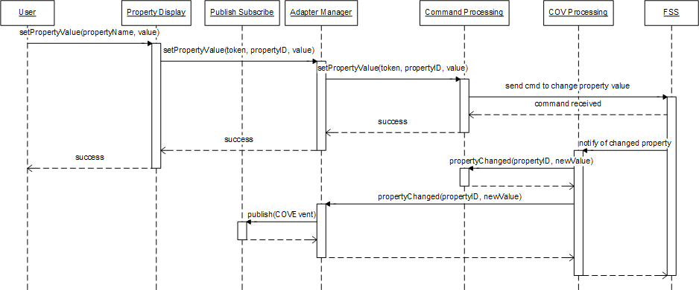
Figure 27: Success scenario during issuing command
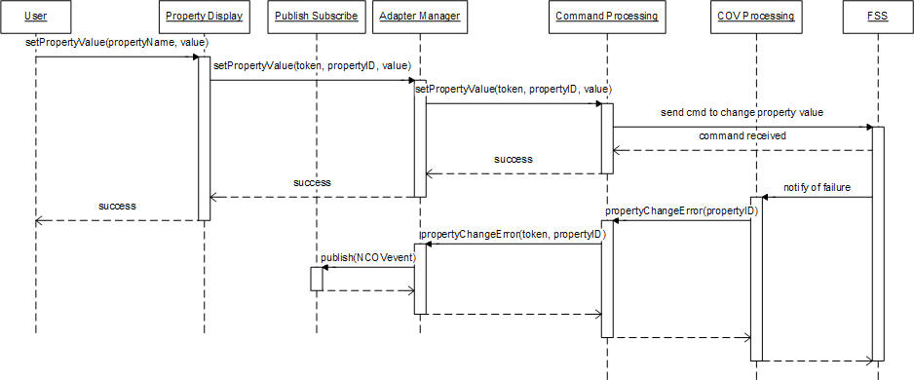
Figure 28: Failure scenario during issuing command

Alarm Rule
The user initiates editing an alarm rule. The user requests to list all the alarms that he/she has access to. To retrieve the set of alarm rules, the user should have read access to all the properties in the rule and a write access to only the Associated Alarm Property. The Rule Editor is the module that handles all the functionality required to edit rules including alarm rules. The user when having a list of all alarms is now allowed to choose a specific rule for editing. The Rule Editor recognizes that the user wants to edit a rule and hence, retrieves all the properties based on the user's permissions.
The user performs all the necessary editing to the rule and then saves it. The Rule Editor will perform two operations:
- Save the new alarm rule to the Repository
- Notify the Alarm Rule Engine that a rule has been edited.
After either of the operations, the user will get a confirmation that the rule has been edited. For the Alarm Rule Engine, the edited alarm rule triggers the system to subscribe or unsubscribe for specific COV events depending on the type of editing the user chose(creation, deletion, updating) and the properties involved in the rule.
The following subsections show sequence diagrams when working with rules.

Display Alarm Rules
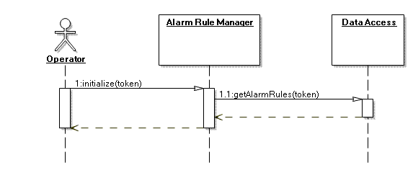
Figure 29: Display Alarm Rules sequence diagram

Delete Alarm Rules
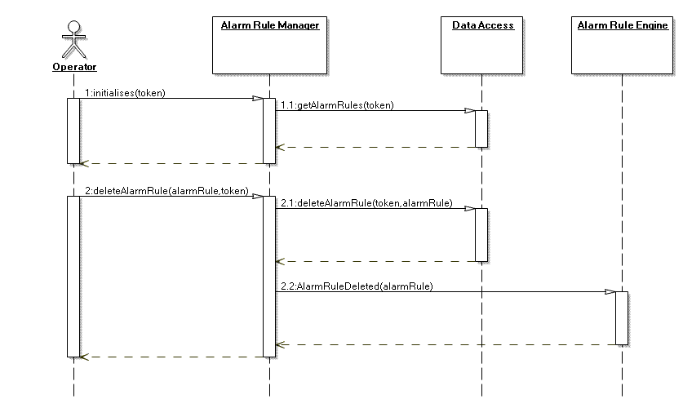
Figure 30: Delete Alarm Rules sequence diagram

Duplicate Alarm Rules
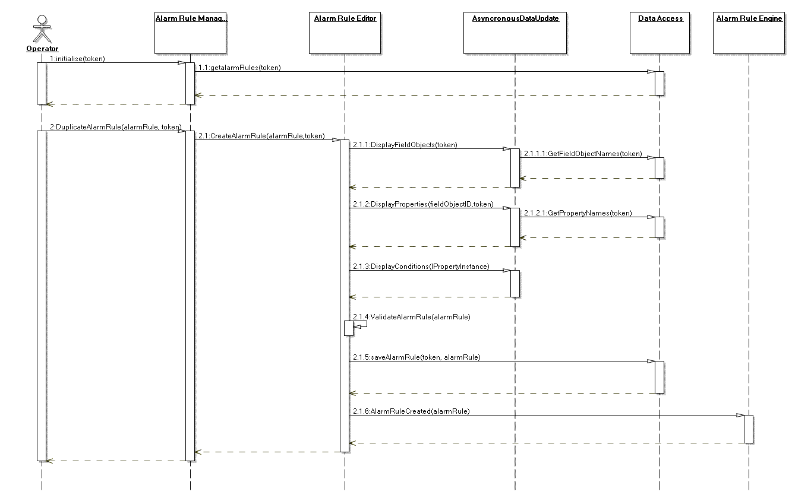
Figure 31: Duplicate Alarm Rules sequence diagram

Change Alarm Rule Status
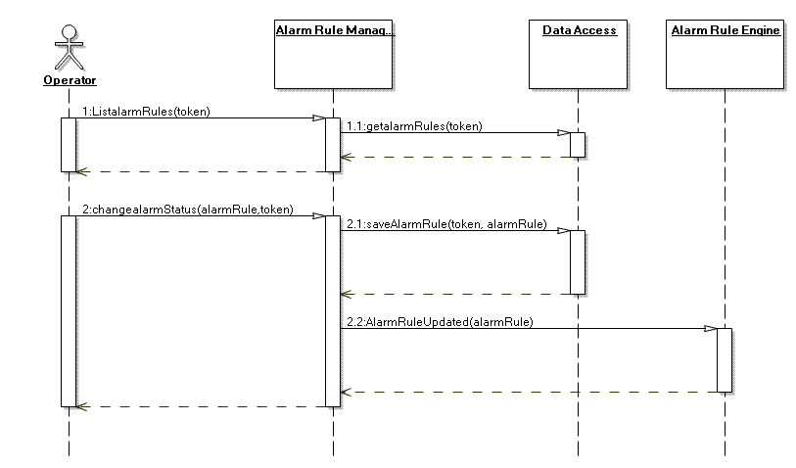
Figure 32: Change Alarm Rule Status sequence diagram

Create Alarm Rule
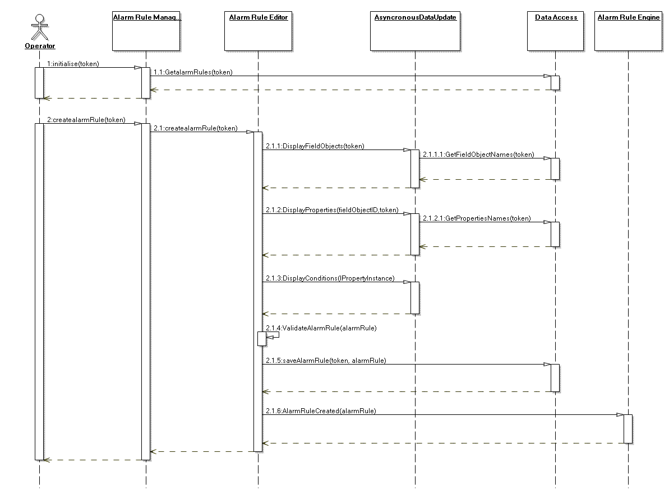
Figure 33: Create Alarm Rule sequence diagram

Edit Alarm Rule
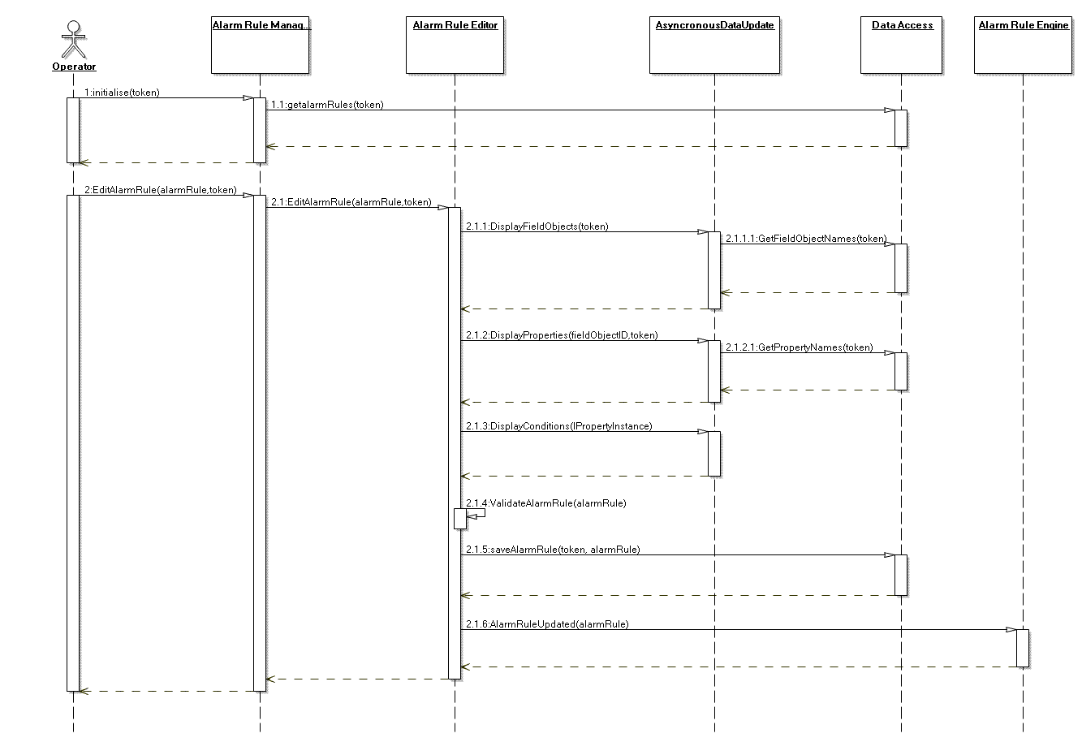
Figure 34: Edit Alarm Rule sequence diagram

Display L&R Rules
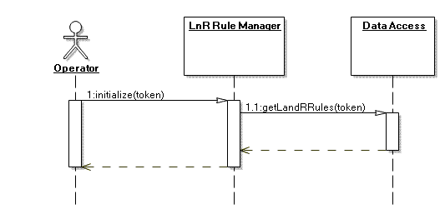
Figure 35: Display L&R Rules sequence diagram

Delete L&R Rules
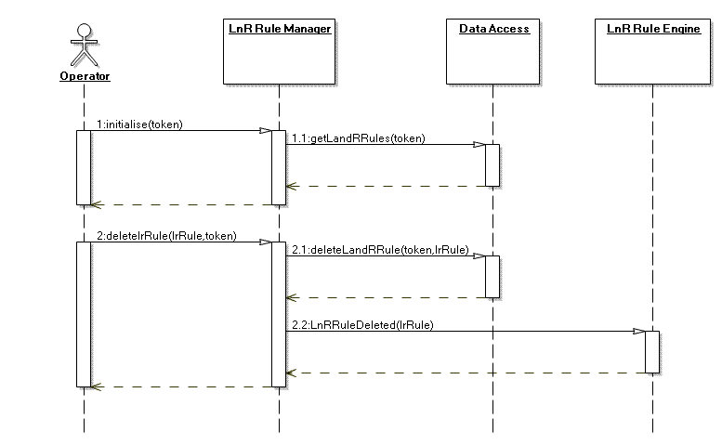
Figure 36: Delete L&R Rules sequence diagram

Duplicate L&R Rules
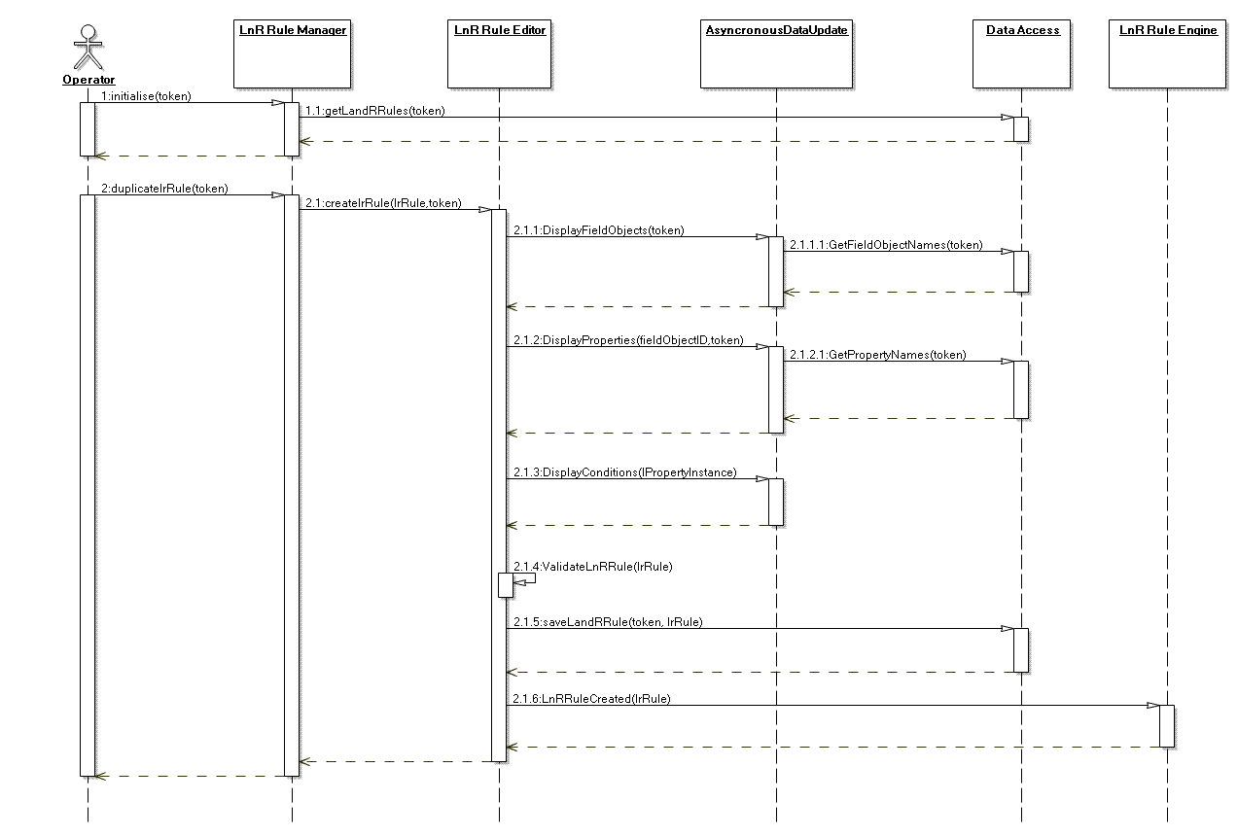
Figure 37: Duplicate L&R Rules sequence diagram

Change L&R Rule Status
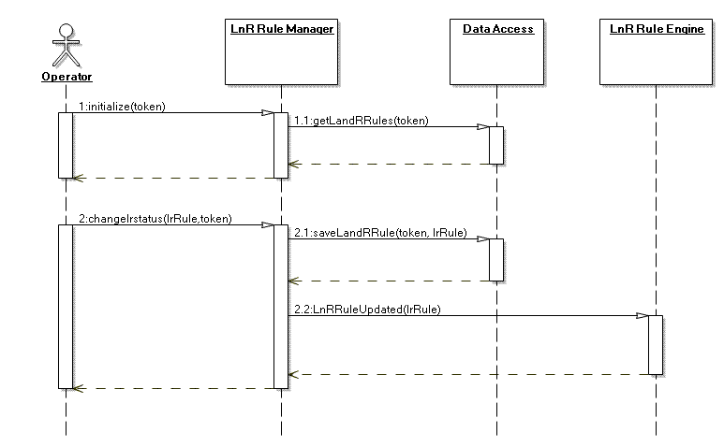
Figure 38: Change L&R Rules sequence diagram

Create LnR Rule
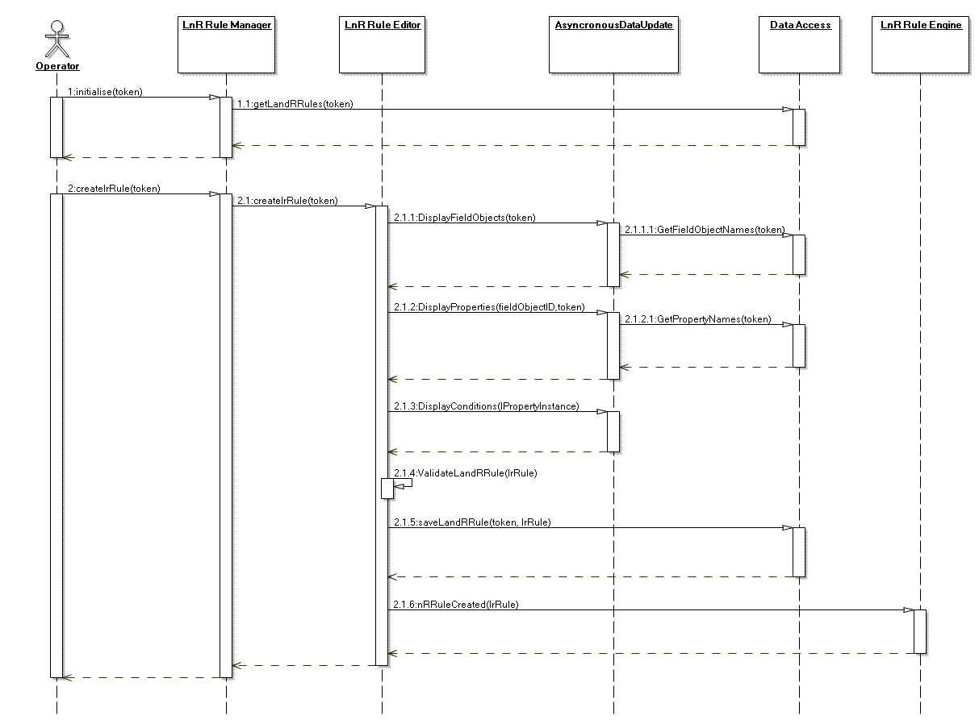
Figure 39: Create L&R Rules sequence diagram

Edit LnR Rule
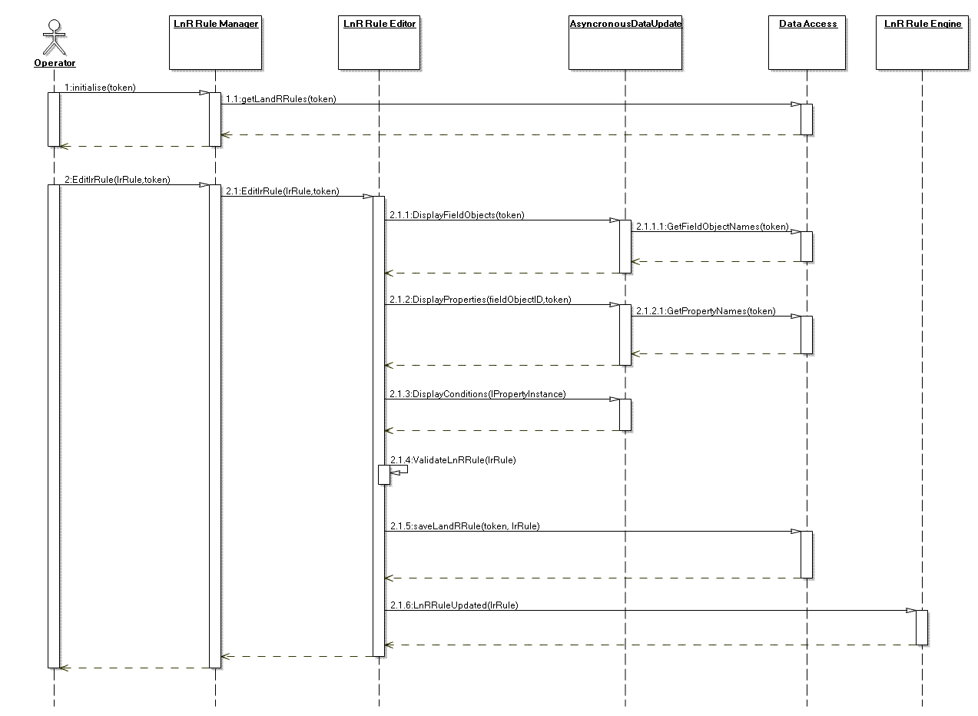
Figure 40: Edit L&R Rule sequence diagram

Publish COV
The FSS notifies MSLite of a change of value on a property. The COV Processing is the first module in MSLite that receives notifications from the FSS. The COV Processing module performs translation of the FSS event to an MSLite notification. This translation of the notification data structure is based on the interface that is in the Adapter Manager. It then proceeds to notify the Adapter Manager that the FSS has notified MSLite of a value change in the property. The Adapter Manager collects the information and then proceeds to prepare it for publishing to the Publish-Subscribe module of MSLite.
The Publish-Subscribe module upon receiving the event will notify the appropriate subscribers of the event. For this sequence diagram, all 4 subscribers (Property Display, Value Cache, Alarm Rule Engine, and L&R Rule Engine) get notified concurrently.
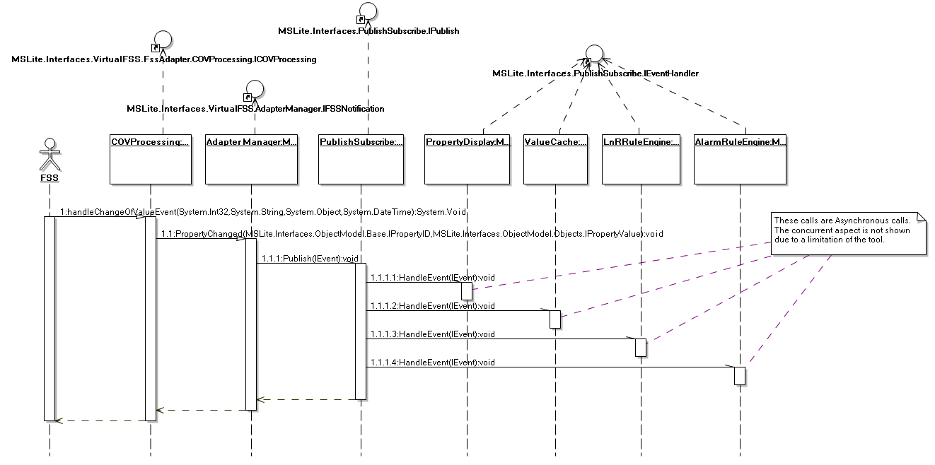
Figure 41: Publish COV sequence diagram

Generate Alarm

Based on MSLite Alarm Rules
The Publish-Subscribe notifies the Alarm Rule Engine that a new COV event has been sent from the FSS to MSLite. The Alarm Rule Engine receives the COV event and inspects the message that identifies the property that had its value changed. The module will send all alarm rules with the property ID and the new value to Condition Evaluation to evaluate which rules need to be executed. Based on the number of properties that exist in a single rule, the Condition Evaluation will request a value for the properties from the Value Cache. After evaluating all the alarm rules, the Condition Evaluation will send back a set of rules that have to be executed in MSLite.
Upon receiving the list of alarms to be executed, the Alarm Rule Engine then sends one rule at a time to the Alarm Processing. The Alarm Processing will then perform two operations in sequence:
- Generate alarm objects that will be persisted to the Repository.
- Notify the AlarmManager about these new alarm objects.
The Alarm Rule Engine will continue to supply these rules to the Alarm Processing until there is no more alarms to be notified.
The Alarm Manager notifies every Alarm Display with access rights the new generated alarm object. Alarm Display is responsible for displaying alarms to the user.
The above behavior does not include the modifiability scenario whereby an FSS can generate alarms. See the diagram in Figure 42 for this case.
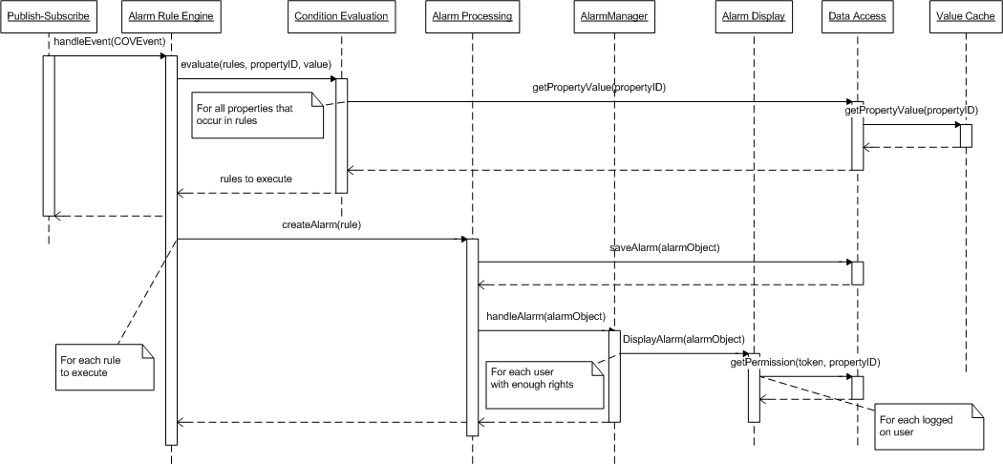
Figure 42: Alarm generation sequence diagram for MSLite

Based on FSS Alarms
This behavior shows the actions taken by the MSLite system when the alarm is created from the FSS. The FSS notifies MSLite that an alarm has been generated internally and wishes to show the alarm to the users. The COV Processing is subscribed to receive this event from the FSS and hence gets notified of a new external alarm. It then translates the FSS alarm to an MSLite external alarm object. This is done to allow communication between other modules in MSLite. The COV Processing forwards this externalAlarmObject to the Adapter Manager in which it then forwards it to the Publish-Subscribe module after creating the appropriate alarm event.
The Publish-Subscribe module notifies the Alarm Processing that a new alarm has been created in the FSS. It receives this alarm event and does two operations in sequence:
- Saves the alarm to the Repository
- Notifies the Alarm Display that a new alarm has been created.
The Alarm Display module proceeds to evaluate which users have access to the alarm by communicating with the Data Access module.
This behavior is created to address the modifiability scenario for an extended FSS with alarm and function commands. See the diagram in Figure 43 for this case.
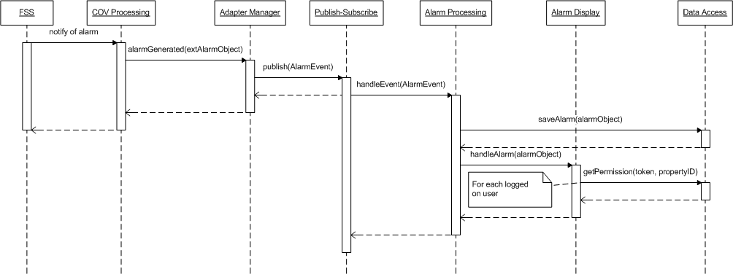
Figure 43: FSS alarm generation sequence diagram

Acknowledge Alarm
The user acknowledges a specific alarm. The Alarm Display is responsible for taking in request from the user and thus sending an acknowledgement call to the AlarmManager with the user's valid token and the alarm object that is to be acknowledged.
The AlarmManager does two operations in sequence:
- Acknowledges the call from the user and persists it to the Repository by modifying the alarm state to "acknowledged"
- Sends an acknowledgement command to the FSS if the alarm was originating from the FSS instead of MSLite. Internally, this is done by sending the command to the Adapter Manager which forwards it to the appropriate Command Processing module for preparation. It then proceeds to issue the alarm command to the FSS. This operation is only possible if the FSS handles alarms.
Only after all acknowledgements are done (both in MSLite and in FSS), will the user get a confirmation message saying that the acknowledgement operation has completed successfully. The AlarmManager module also updates the user interfaces of all other users to show the alarm as acknowledged.
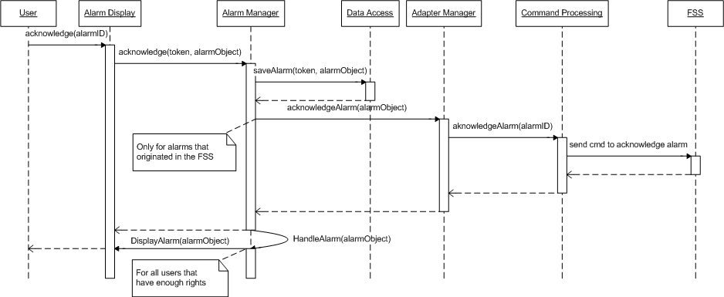
Figure 44: Acknowledge Alarm sequence diagram

Dismiss Alarm
The user dismisses a specific alarm. The Alarm Display is responsible for taking in the request from the user and thus sending a dismiss call to the AlarmManager with the user's valid token and the alarm object that is to be removed.
The AlarmManager does three operations in sequence:
- Checks whether the user has write access right to the alarm and the alarm is already acknowledged.
- Dismisses the call from the user and persists it to the Repository by removing the alarm from it
- Sends an dismiss command to the FSS if the alarm was originating from the FSS instead of MSLite. Internally, this is done by sending the command to the Adapter Manager which forwards it to the appropriate Command Processing module for preparation. It then proceeds to issue the alarm command to the FSS. This operation is only possible if the FSS handles alarms.
Only after the dismiss process is done (both in MSLite and in FSS), will the user get a confirmation message saying that the dismissing operation has completed successfully. The AlarmManager module also updates the user interfaces of all other users to remove the alarm from the display.
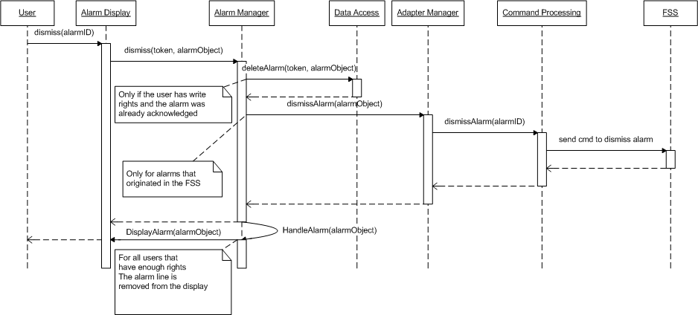
Figure 45: Dismiss Alarm sequence diagram

Configuration Synchronization
During startup of MSLite, the system has to be synchronized with the FSSs in terms of the field objects and their respective property values. Before any synchronization occurs, MSLite will clear all configurations and hence will avoid any duplications or complexity in code to handle data redundancy.
One requirement for MSLite is to know exactly where the Adapters in MSLite reside. For synchronization the steps are:
- Retrieve all object templates that reside in the FSS configuration file via the Configuration module.
- Persist these templates into the database
- Retrieve all object instances based on the object templates via the Configuration Module. This includes all properties for the associated object instance.
- Retrieve property values from the FSS via the Configuration module.
- It then saves all properties and their values to the Value Cache module.
This behavior is a prerequisite for running the system.
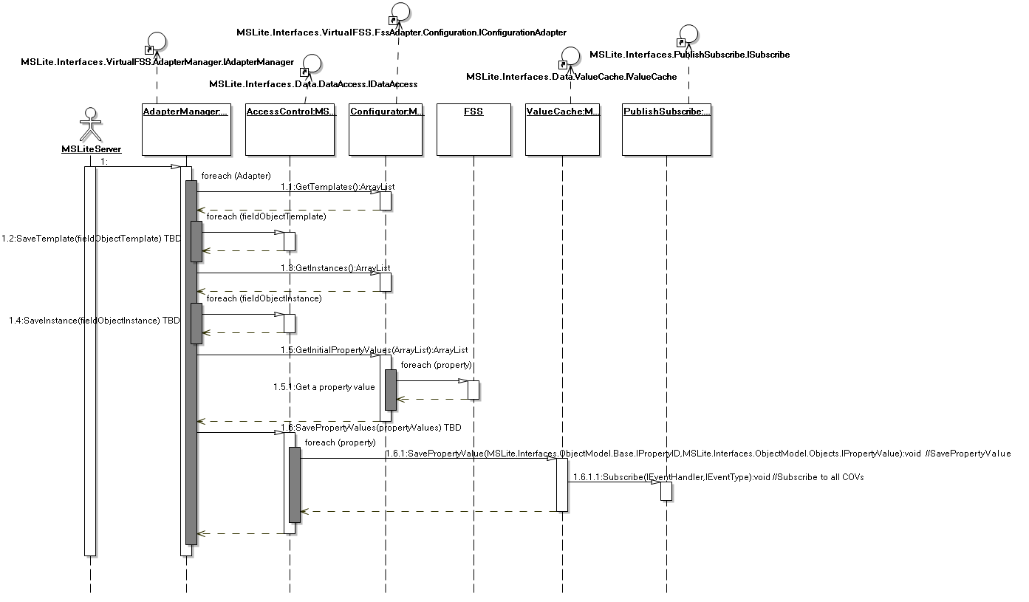
Figure 46: Configuration Synchronization sequence diagram

MSLite Startup
The diagrams in Figure 47, Figure 48 and Figure 49 show what happens when an administrator starts MSLite. We assume that the field system simulators, web server, and the database service are already running. We assume further that it is preferable to manually start the executables for the processes that make up MSLite to have more control over the system.
The first step is to start up the MSLite server process, which initializes the adapter manager and value cache. The adapter manager instantiates adapters for each FSS according to the system configuration. This also includes reading the FSS configuration into MSLite as shown in the previous section Configuration. Initialization of the value cache includes that the value cache subscribes to all COV events for all properties.
Next the Alarm and L&R processes are started. Both processes retrieve the respective rules and subscribe to COV events for properties that occur in their respective rule sets.

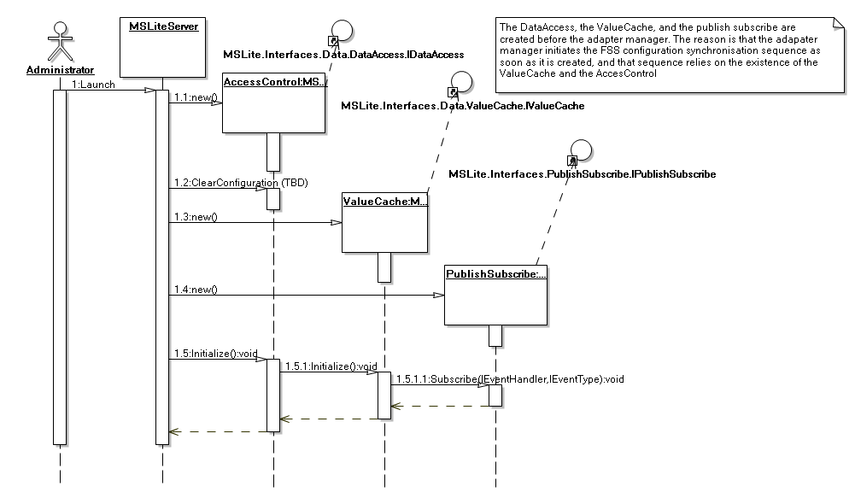
Figure 47: MSLite Startup sequence diagram showing initialization of Value Cache
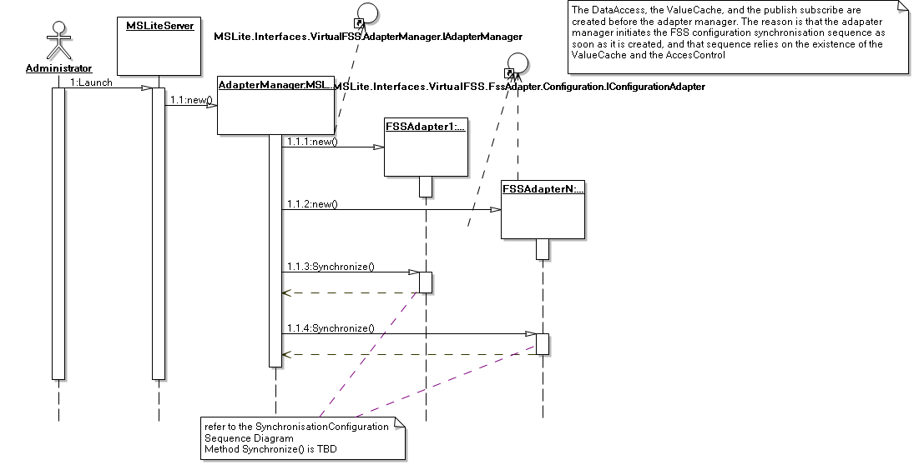
Figure 48: MSLite Startup sequence diagram showing initialization of Adapter Manager
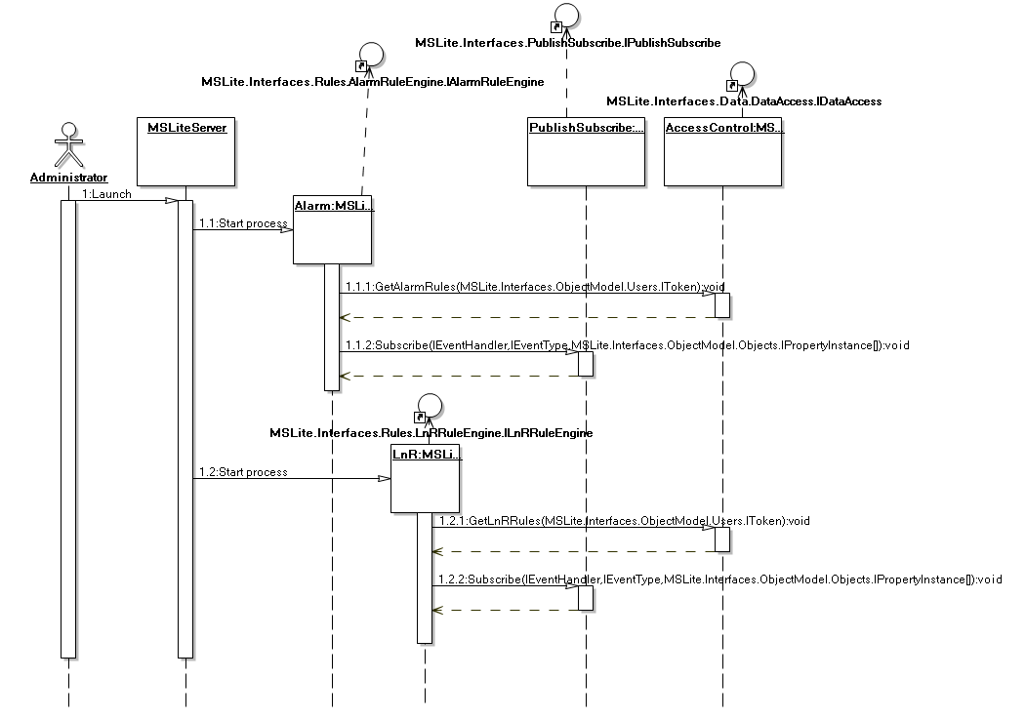
Figure 49: MSLite Startup sequence diagram showing initialization of Alarm and L&R processes

